SUBCOURSE EDITION
IT 0343 A

US ARMY INTELLIGENCE CENTER
BASIC CONCEPTS
OF
BOOLEAN ALGEBRA CONVERSIONS

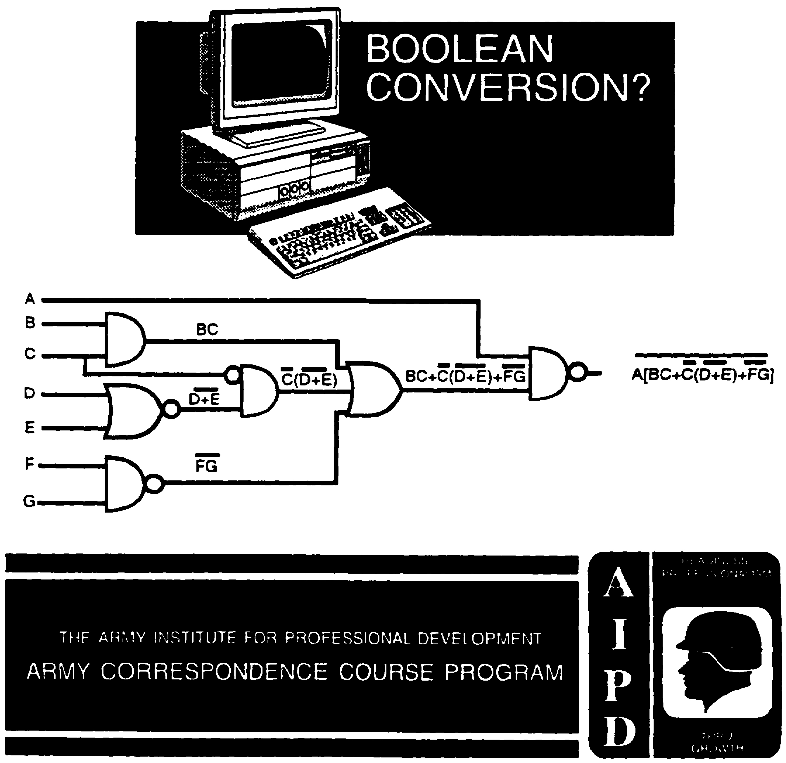

BASIC CONCEPTS OF BOOLEAN ALGEBRA CONVERSION

Subcourse Number IT 0343

EDITION A

US ARMY INTELLIGENCE CENTER
FORT HUACHUCA, AZ 85613-6000

5 Credit Hours

Edition Date: December 1996

SUBCOURSE OVERVIEW

This subcourse is designed to teach you to convert logic diagrams to Boolean expressions and to convert Boolean expressions to logic diagrams.

This Subcourse replaces SA 0713.

Prerequisites for this subcourse is IT 0342.

TERMINAL LEARNING OBJECTIVE

ACTION: You will be able to convert logic diagrams to Boolean expressions.

CONDITION: Given the information in this subcourse.

STANDARD: To demonstrate competency of this task, you must achieve a minimum of 70% on the subcourse examination.

i IT 0343

TABLE OF CONTENTS

Section Page

Subcourse Overview i

Lesson 1: Conversion of logic diagrams to Boolean expressions 1-1

Lesson 2: Conversion of Boolean expressions to logic diagrams 2-1

IT 0343 ii

LESSON 1

CONVERSION OF LOGIC DIAGRAMS TO BOOLEAN EXPRESSIONS

OVERVIEW

LESSON DESCRIPTION:

In this lesson you will learn how to convert logic diagrams to Boolean expressions.

TERMINAL LEARNING OBJECTIVE:

ACTION: Conversion of logic diagrams to Boolean expressions.

CONDITION: Given the information in this lesson.

STANDARD: To demonstrate competency of this task, you must achieve a minimum of 70% on the subcourse examination.

SPECIAL INSTRUCTIONS:

There are exercises on most pages of this lesson, and some pages have multiple exercises. After you work each exercise, check your solution to the corresponding answer on the following page.

1-1 IT 0343

1. A logic diagram which contains only an AND operation or only an
OR operation is called a first-order-logic diagram.
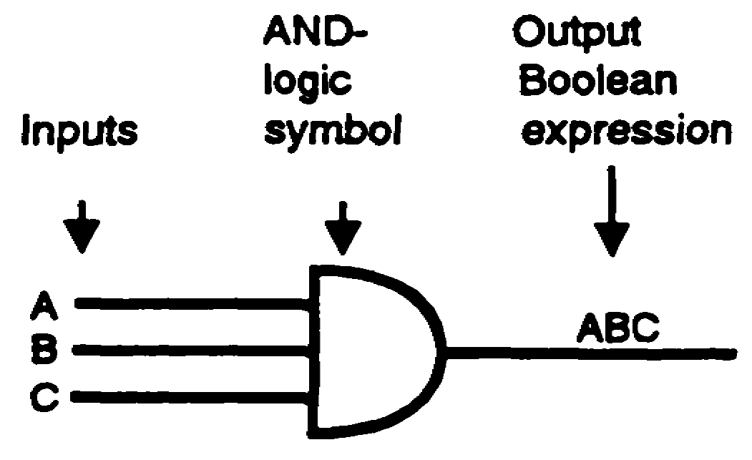
The diagram above is an example of first-order logic for an AND
circuit with three inputs. To convert this diagram correctly to a
Boolean expression, first, identify the symbol as an AND-logic
symbol. Notice that there are three separate inputs. Be sure to
include all the inputs in the output Boolean expression. The correct
output Boolean expression for the logic diagram above is written
ABC.
Write the output Boolean expression for the first-order-logic AND
diagram below.


1-3 IT 0343

RAY | 2.
 | 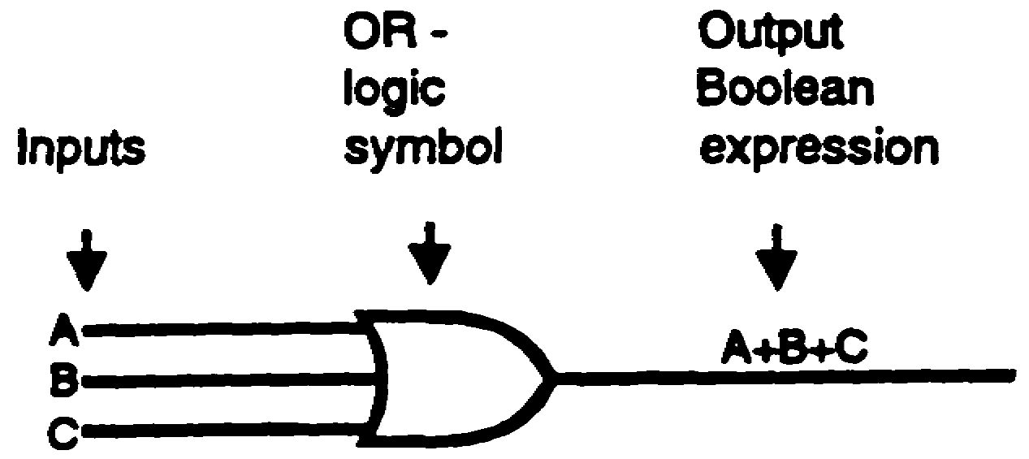
 | The diagram above is an example of first-order logic for an OR
 | circuit with three inputs. The output Boolean expression for this
 | diagram is written A+B+C.
 | Write the output Boolean expression for the first-order-logic OR
 | diagram below.
 | 

IT 0343 1-4

A+K+E | 3. Convert the logic diagrams below to Boolean expressions.
 | a.
 | 
 | b.
 | 
 | c.
 | 
 | d.
 | 

1-5 IT 0343

a. M+A+N | 4. A logic diagram which contains both an AND and an OR operation
b. THIS | is a second-order-logic diagram.
c. I+S  d. FUN | 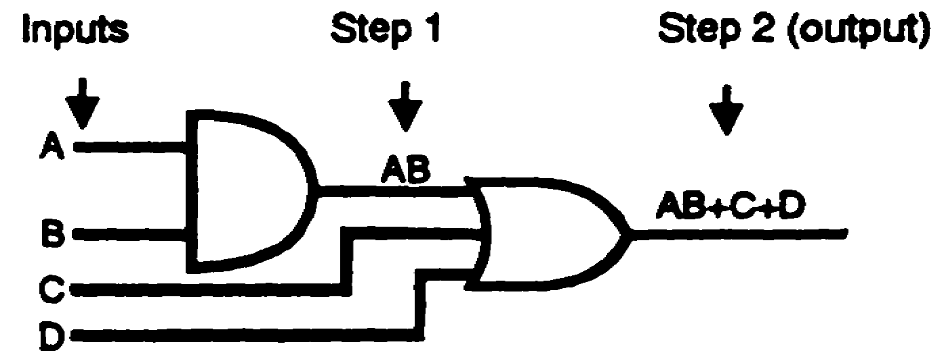
 | The diagram above is an example of second-order logic, an AND
 | circuit supplying an OR circuit. The output of each logic symbol
 | must be determined in order to develop an output Boolean
 | expression correctly. Start with the inputs to the first symbol and
 | proceed to the final output. Use the output of each logic symbol as
 | an input to the next succeeding symbol as follows:
 | Step 1. The first symbol is recognized as an AND gate with two
 | inputs, A and B. The output, AB, in turn, is one of the
 | inputs to the OR gate.
 | Step 2. The final output from this logic diagram is from the OR
 | gate. An examination of the output expression reveals
 | that it is correctly indicating the output from an OR gate
 | which had three separate inputs, AB, C, and D.

IT 0343 1-6

4. (Continued)
Write the output Boolean expression for the second-order-logic
diagram below of an AND circuit supplying an OR circuit.
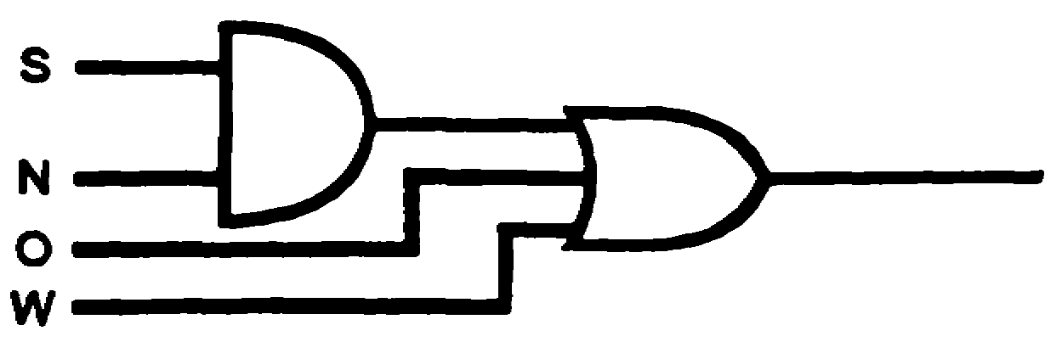
5. The logic diagram above represents _______________ - order logic.
6. Write the output Boolean expression for the logic diagram below.
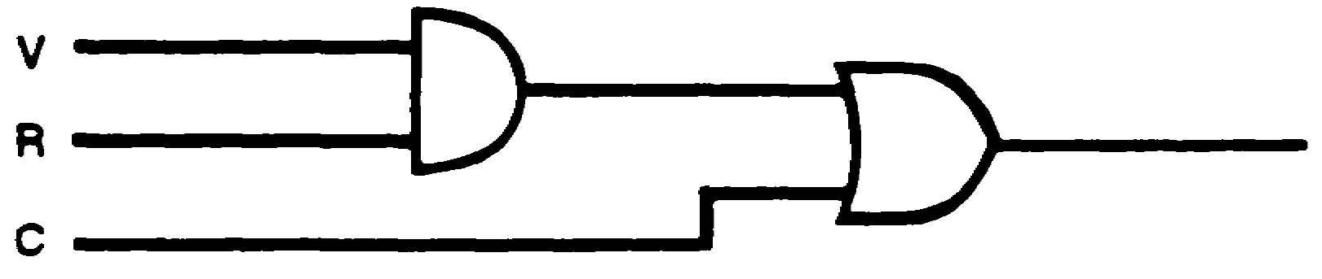

1-7 IT 0343

4. SN+O+W | 7.
5. second | 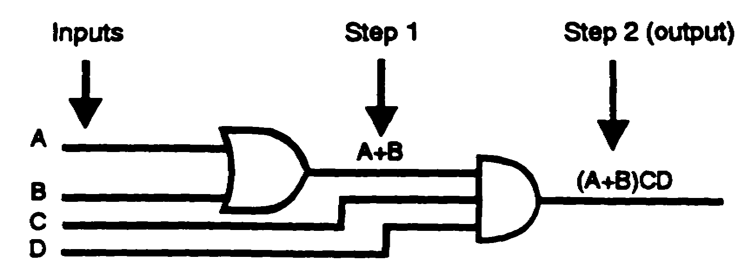
6. VR+C
 | The diagram above is an example of second-order logic, an OR
 | circuit supplying an AND circuit. The output of each logic symbol
 | must be determined in order to develop an output Boolean
 | expression correctly. Start with the inputs to the first symbol and
 | proceed to the final output as indicated. Use the output of each
 | logic symbol as an input to the next symbol. Notice that the output
 | A+B of the OR gate (step 1) is put in parentheses in the final
 | output Boolean expression. It is enclosed in parentheses to
 | indicate that the complete quantity (A+B) is ANDed with CD.
 | Write the output Boolean expression for the second-order-logic
 | diagram below consisting of an OR circuit supplying an AND
 | circuit.
 | 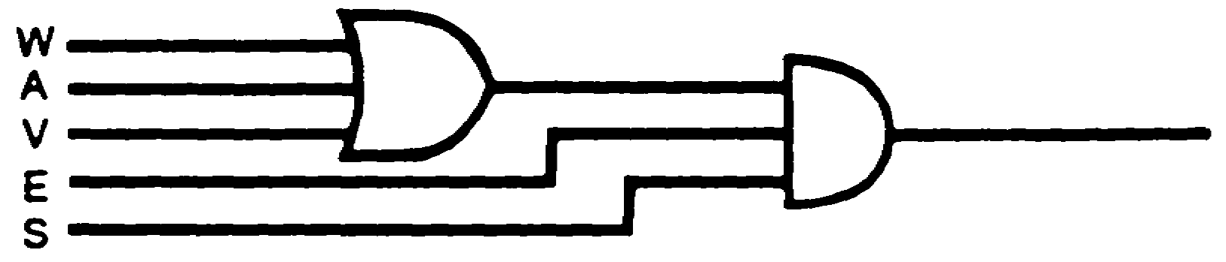

IT 0343 1-8

(W+A+V)ES | 8.
 | 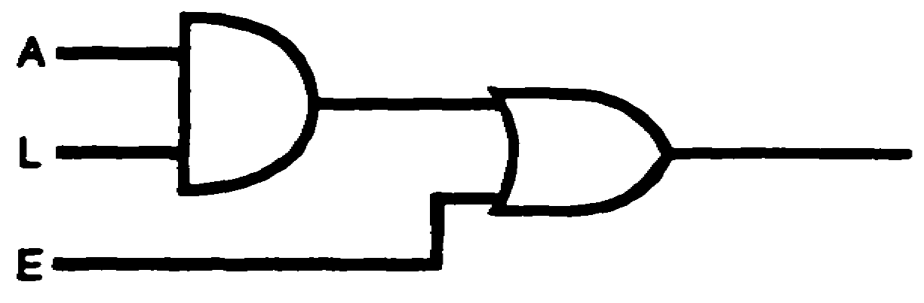
 | The logic diagram above represents ___________ - order logic.
 | 9. Convert the logic diagram below to a Boolean expression.
 | 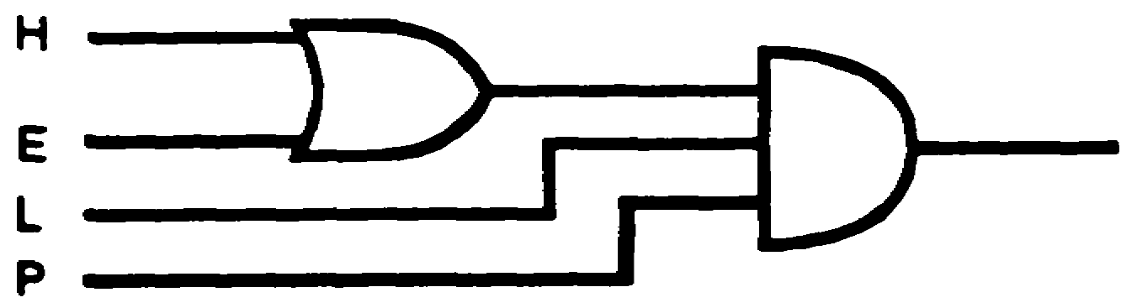
 | 10.
 | 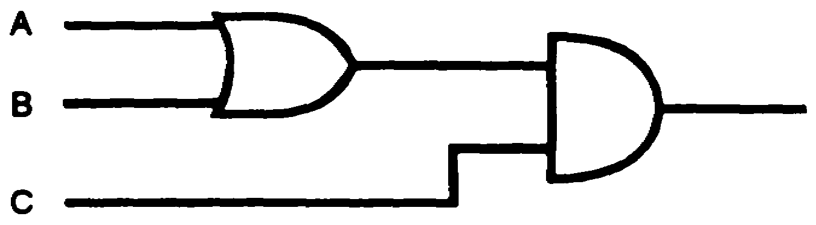
 | The logic diagram above represents ____________ - order logic.
 | 11. Write the output Boolean expression for the logic diagram below.
 | 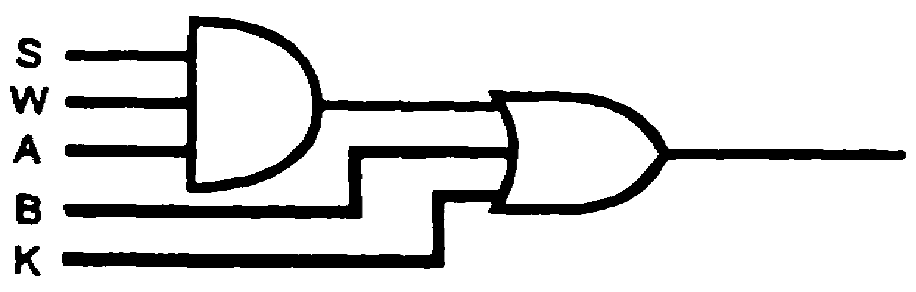

1-9 IT 0343

8. second | 12.
9. (H+E) LP  10. second  11. SWA+B+K | 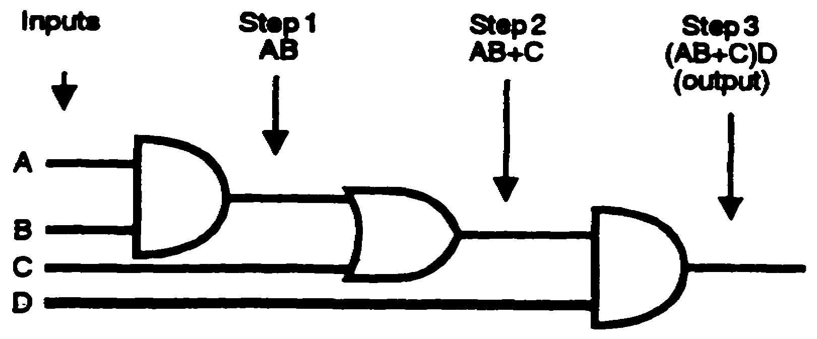
 | A third-order-logic diagram consisting of two AND gates and one
 | OR gate is illustrated above. The logic diagram can be converted
 | to a Boolean expression by using the same procedure of
 | determining the output of each symbol and working systematically
 | to the final output. Note that proper identity and separation are
 | maintained by using parentheses. If the parentheses had not
 | been used, the output Boolean expression would not have been a
 | correct indication of the logic diagram.
 | Write the output Boolean expression for the third-order-logic
 | diagram below containing two AND gates and one OR gate.
 | 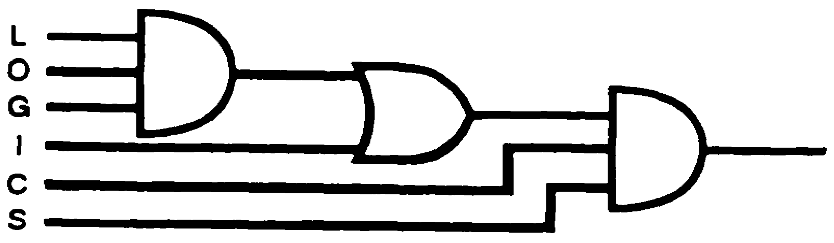

IT 0343 1-10

(LOG+I) CS | 13. Write the Boolean expression for each of the points indicated
 | below.
 | 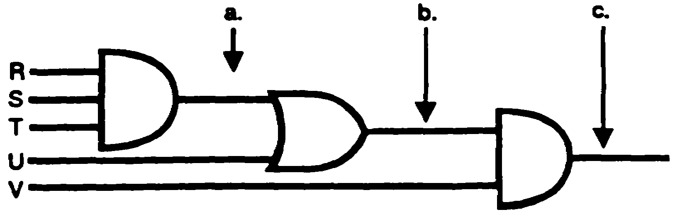
 | 14. Convert the logic diagram below to a Boolean expression.
 | 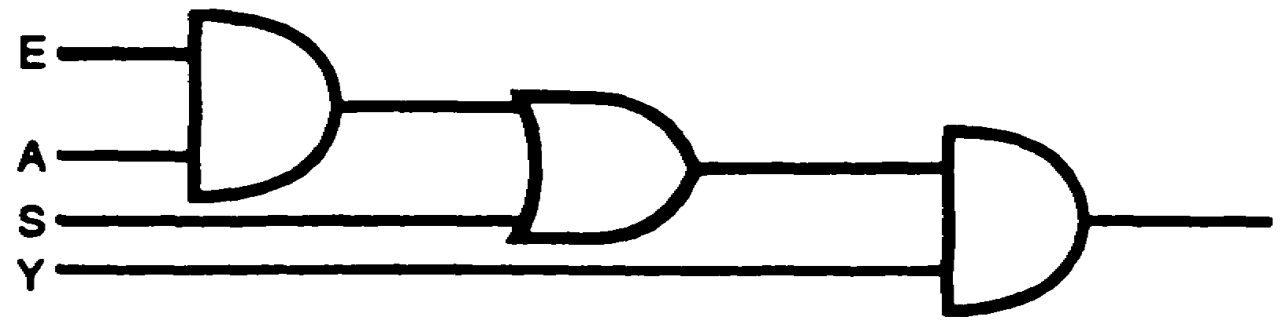
 | 15.
 | 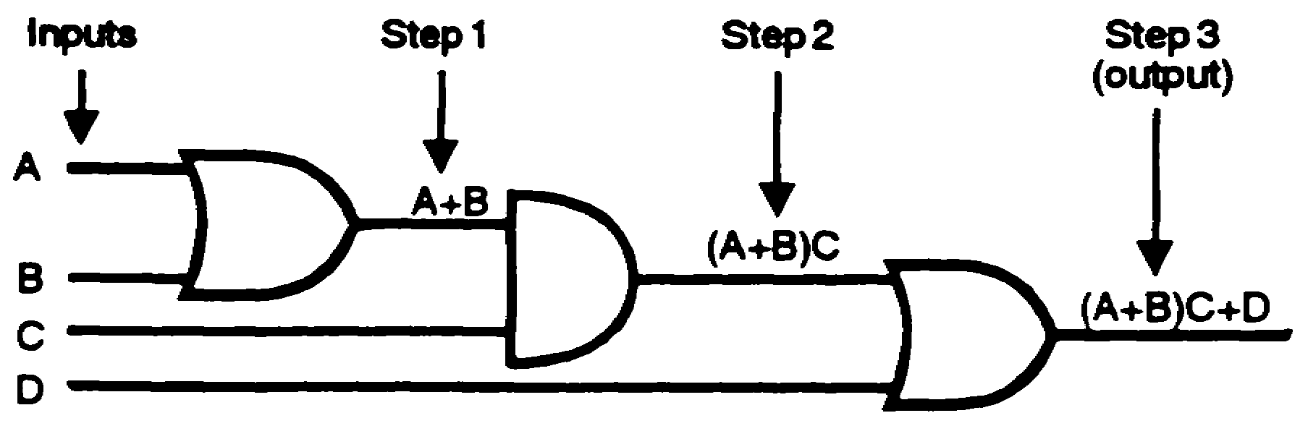
 | A third-order-logic diagram consisting of two OR gates and one
 | AND gate is shown above. Converting this logic diagram to an
 | output Boolean expression is accomplished in the same manner
 | as previously discussed. Maintain proper identity and separation
 | of terms to ensure an output Boolean expression which is a
 | correct indication of the logic diagram.

1-11 IT 0343

13a. RST | 15. (Continued)
b. RST+U | Write the output Boolean expression for the third-order-logic
c. (RST+U) V | diagram below consisting of two OR gates and one AND gate.
14. (EA+S) Y | 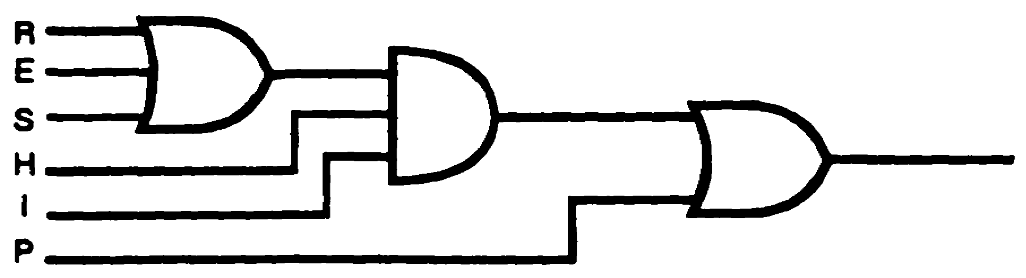
 | 16. Write the Boolean expression for each of the points indicated
 | below.
 | 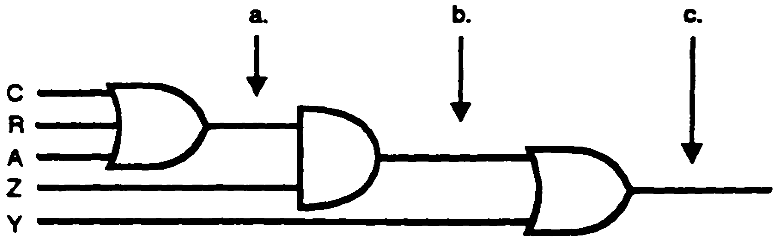
 | a.
 | b.
 | c.
 | 17. Convert the logic diagram below to a Boolean expression.
 | 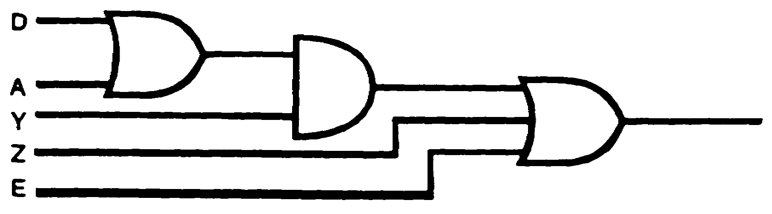

IT 0343 1-12

15. (R+E+S) HI+P | 18. Speed and confidence in the operations required for converting
16a. C+R+A | from a logic diagram to an output Boolean expression can best be
b. (C+R+A) Z | gained through practice. All problems should be solved
c. (C+R+A) Z+Y | systematically to develop the efficiency required of a technician.
17. (D+A) Y+Z+E | 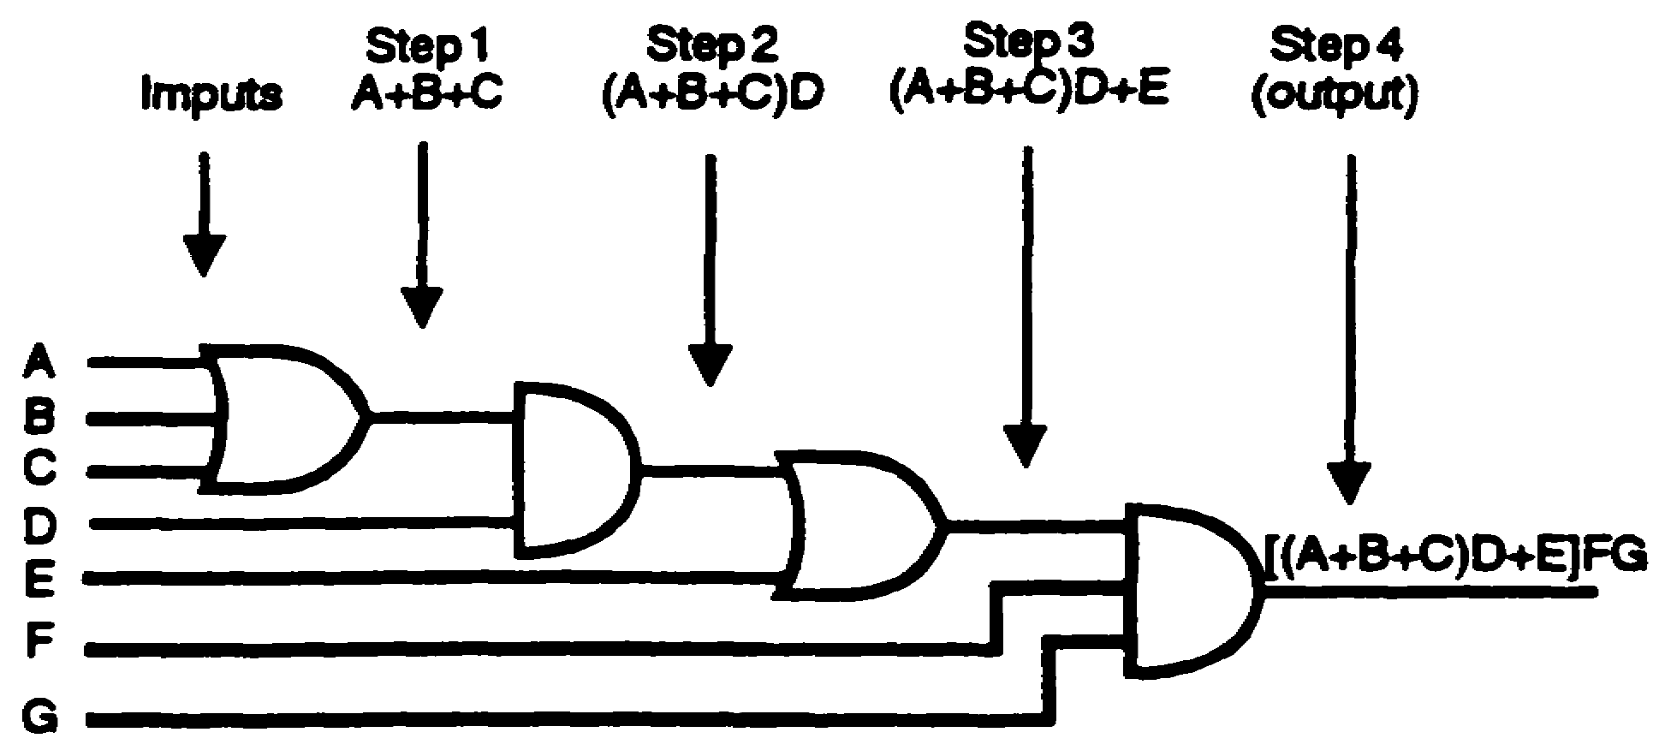
 | The diagram above is an example of a fourth-order-logic diagram
 | consisting of two AND gates and two OR gates. The logic diagram
 | is converted to an output Boolean expression by starting at the
 | inputs, using the step-by-step procedure, and working toward the
 | final output.
 | NOTE: Boolean expressions use parentheses and brackets in the
 | same manner as normal algebra to maintain proper
 | identity and separation of quantities. The quantity
 | (A+B+C) above is ANDed with D and must be shown with
 | parentheses. The quantity [(A+B+C) D+E] is ANDed with
 | FG and must be shown with brackets. If parentheses
 | were used again, the quantity ((A+B+C) D+E) would be
 | confusing.

1-13 IT 0343

18. (Continued)
Write the output Boolean expression for the fourth-order-logic
diagram below consisting of two AND gates and two OR GATES.
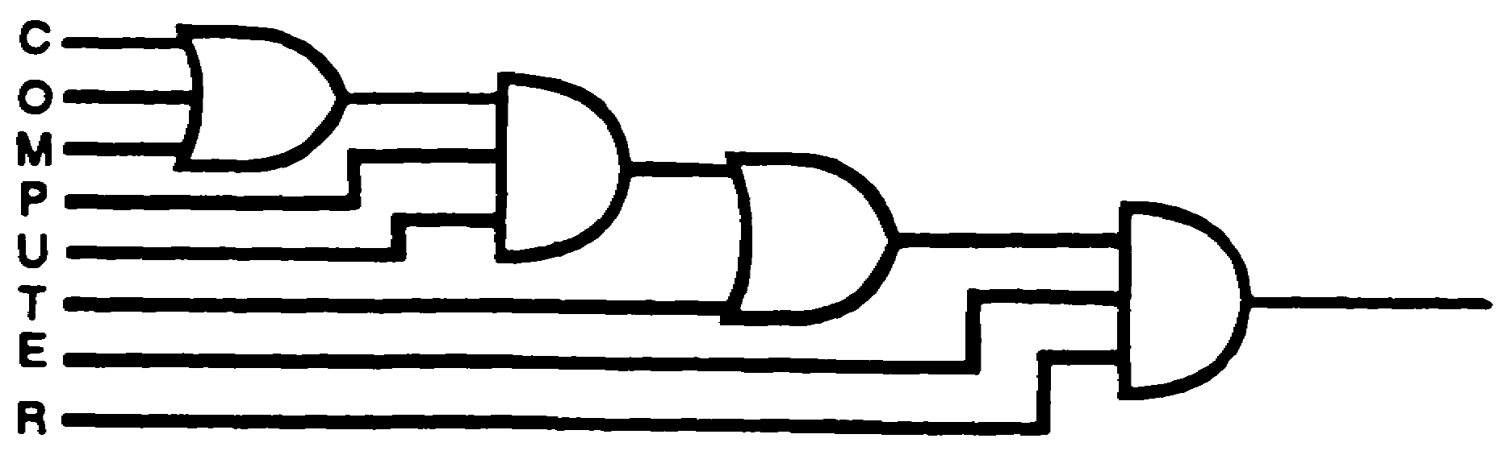
19. Write the Boolean expression for each of the points indicated
below.
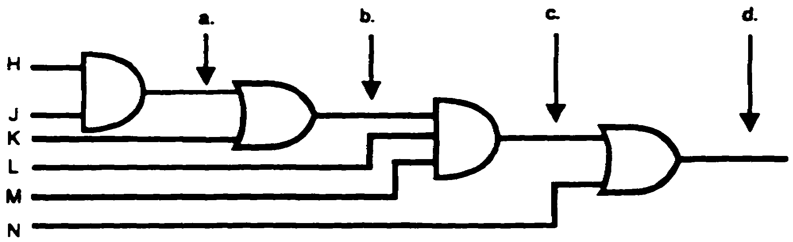
a.
b.
c.
d.
20. Convert the logic diagram below to a Boolean expression.
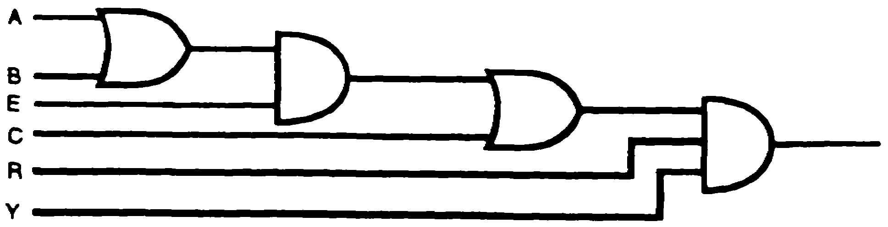

IT 0343 1-14

 | 21. The logic diagram in frame 20 is an example of
 | order logic.
18 [(C+O+M)PU+T]ER | 22.
19a. HJ  b. HJ+K  c. (HJ+K) LM  d. (HJ+K) LM+N  20. [(A+B)E+C]RY | 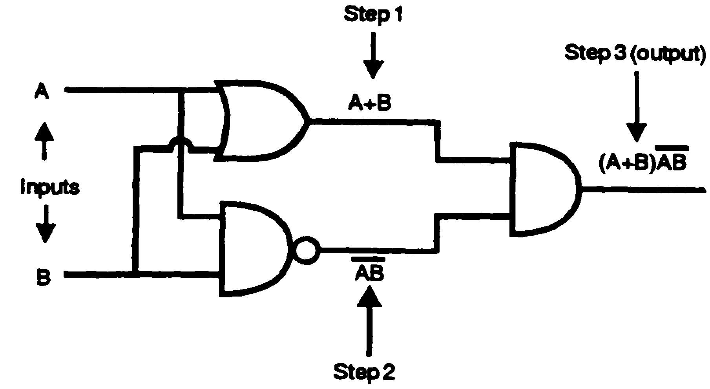
 | An output Boolean expression is obtained from the logic
 | diagram above in the same manner as the other diagrams
 | previously discussed. An output Boolean expression can be
 | systematically achieved by starting from the inputs and labeling
 | the output of each symbol as indicated.
 | Write the output Boolean expression for the logic diagram
 | below containing an AND gate, an OR gate, and a NOR gate.
 | 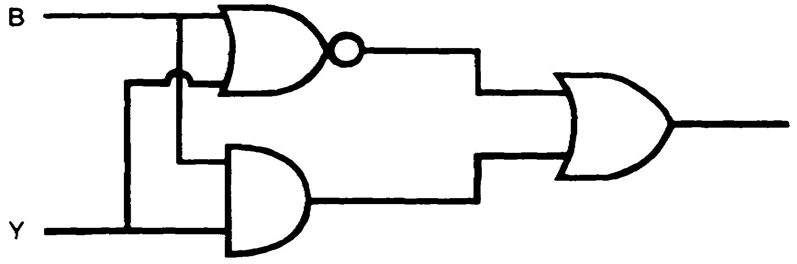

1-15 IT 0343

21. fourth | 23. Write the Boolean expression for each of the points indicated
22. (B+Y) +BY | below.
 | 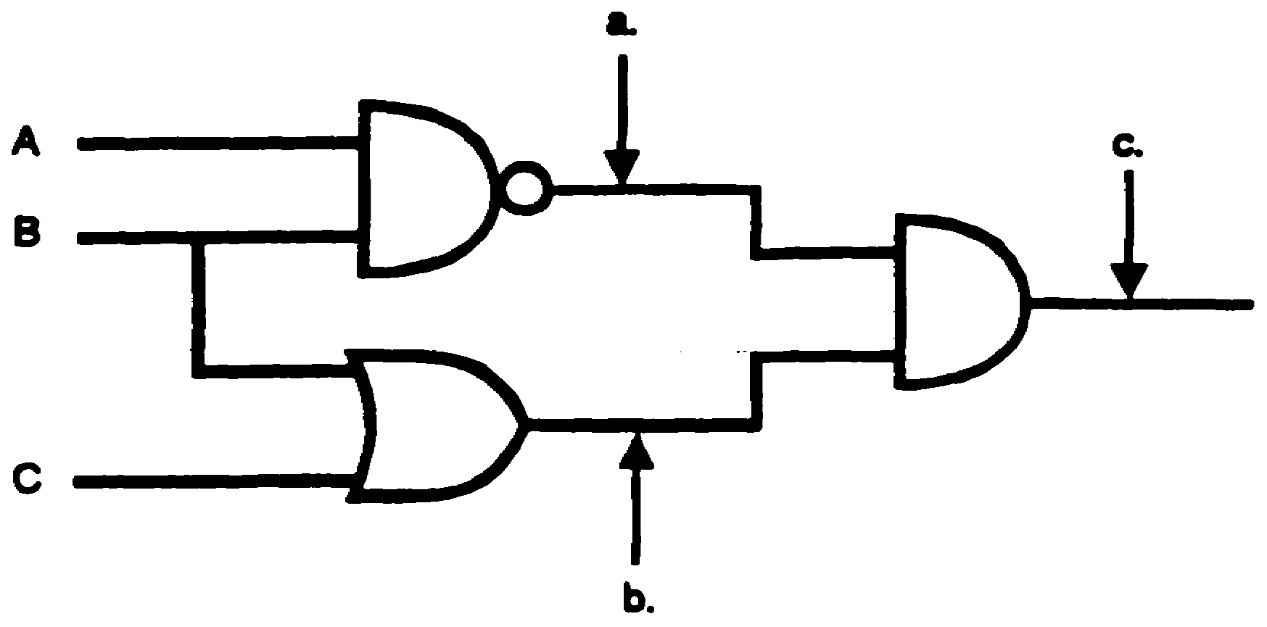
 | a.
 | b.
 | c.
 | 24. Convert the logic diagram below to a Boolean expression.
 | 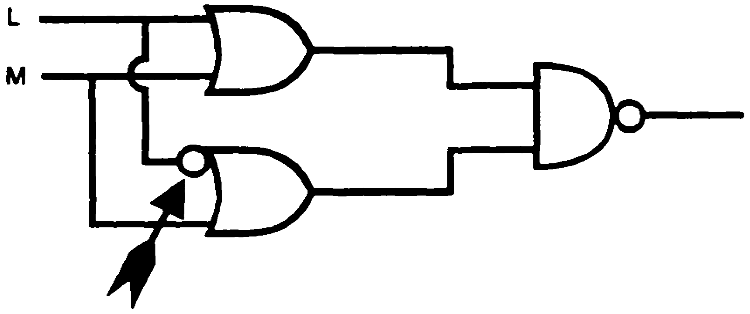
 | This symbol is an inverter which inverts only the one input.

IT 0343 1-16

23a. AB | 25.
b. B+C  c. AB (B+C)  24. (L+M)(L+M) | 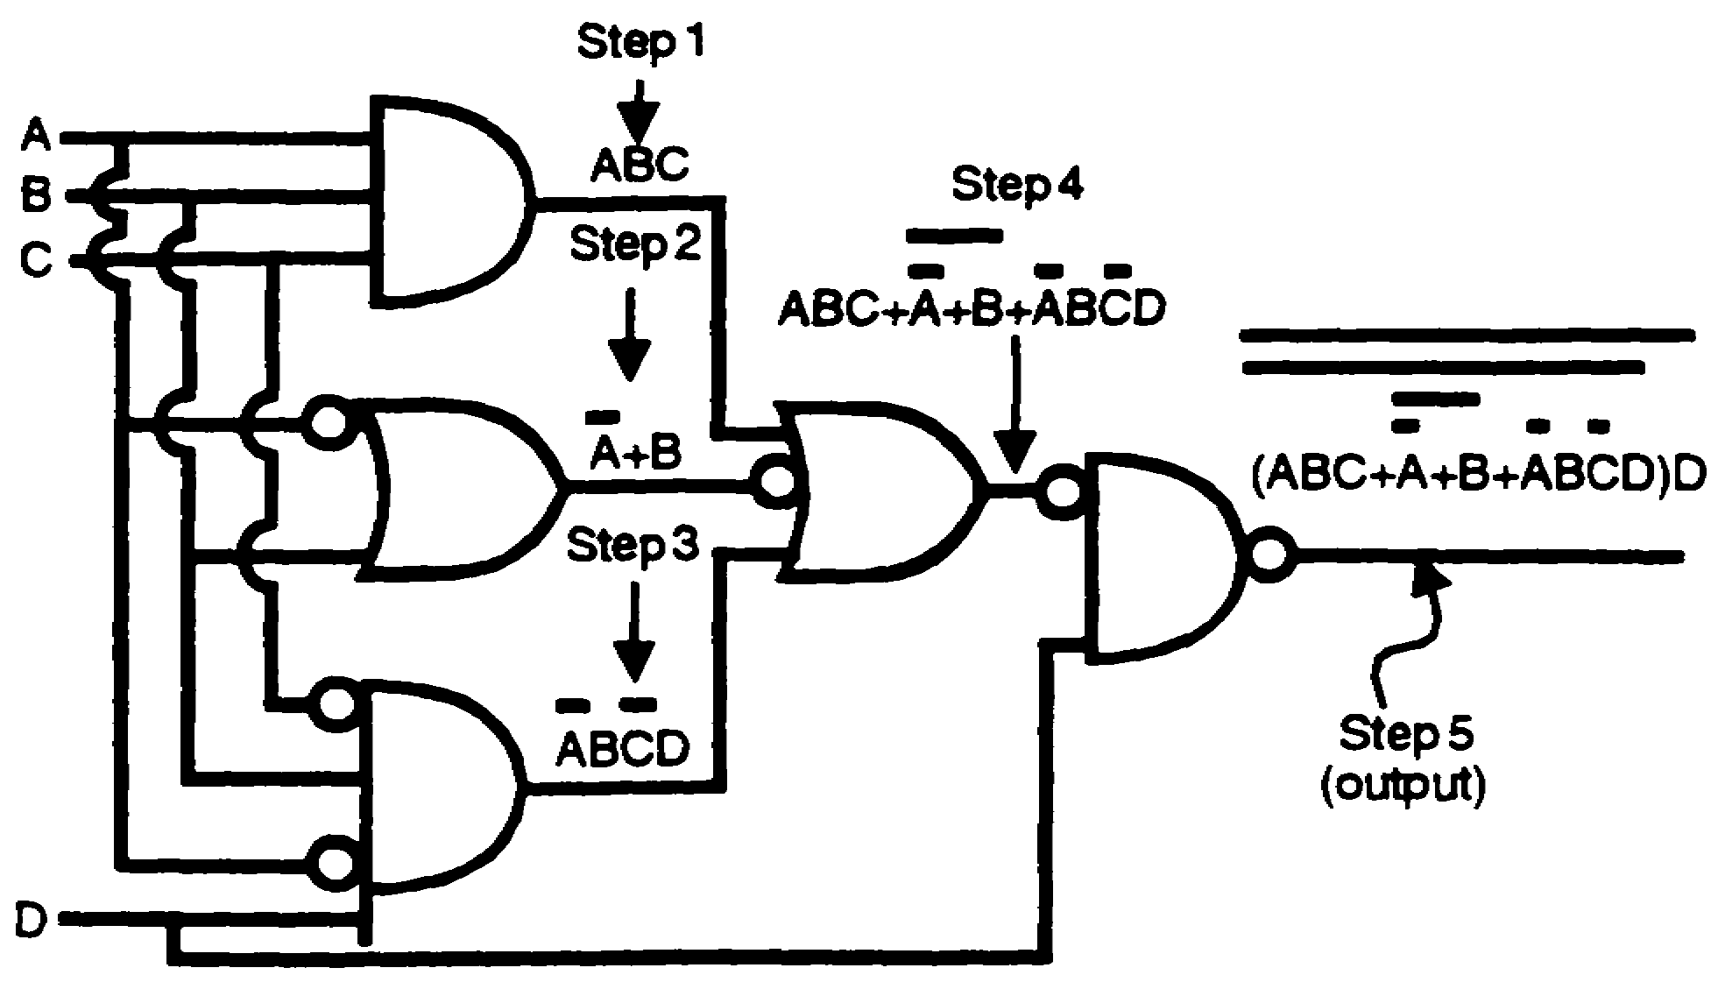
 | The logic diagram above contains a combination of various logic
 | symbols. Although this diagram is more complex than others
 | previously encountered, it is systematically converted to an output
 | Boolean expression by using the step-by-step procedure illustrated
 | in the diagram. Be careful not to lose track of an inverted input or
 | output. Maintain proper identity and separation by using
 | appropriate marks of separation. A good habit to develop is to
 | doublecheck the results for completeness and accuracy.
 | Write the output Boolean expression for the logic diagram below.
 | 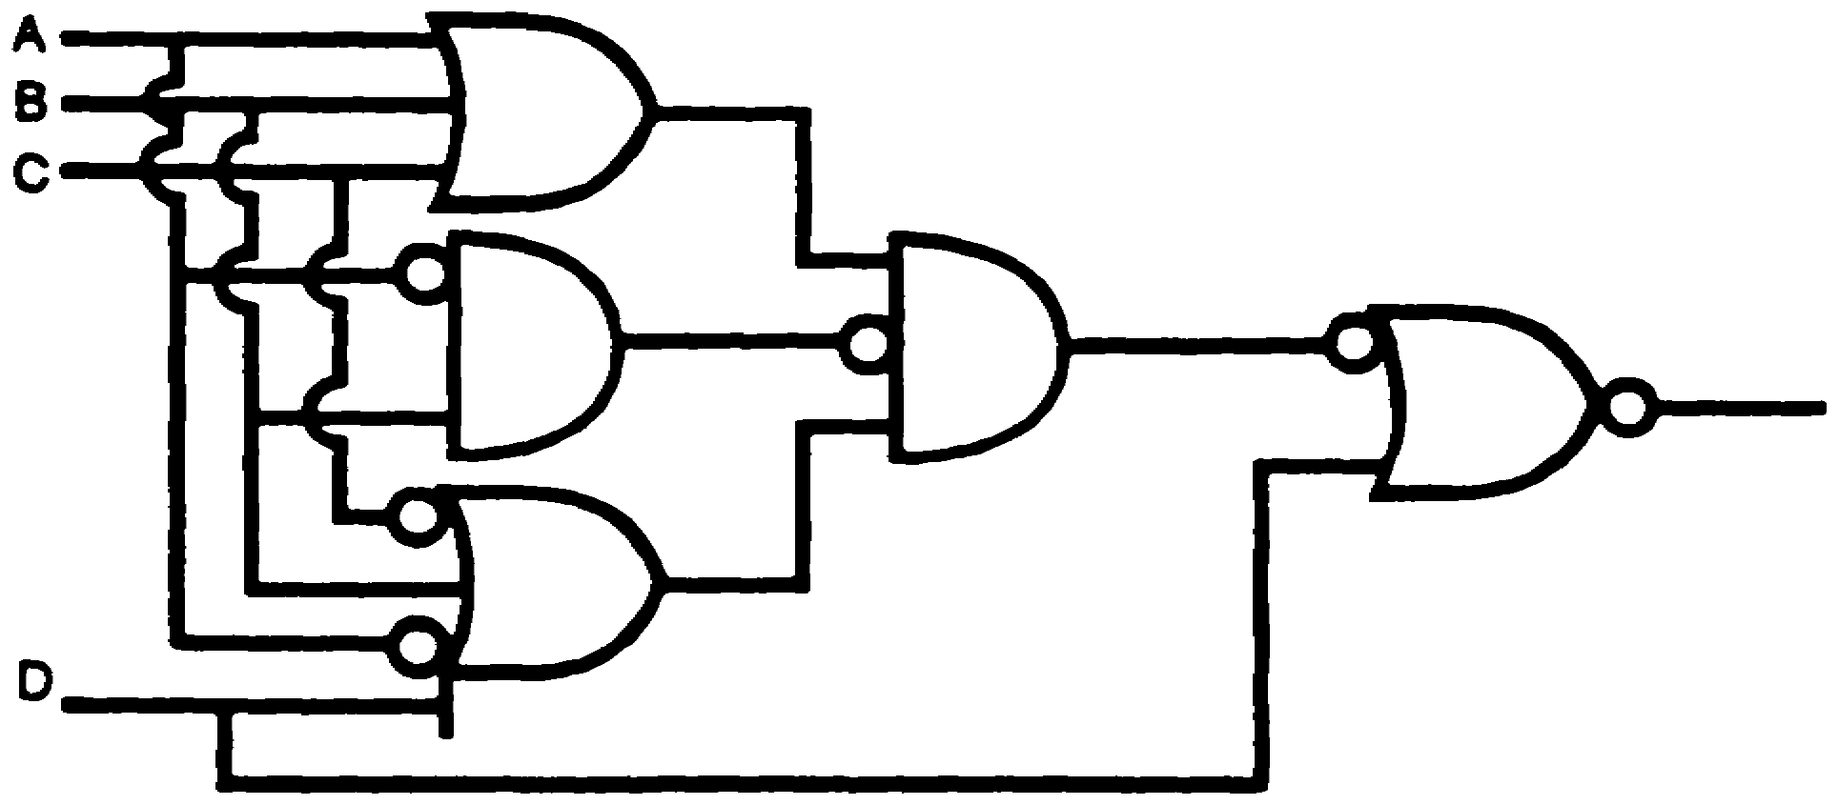

1-17 IT 0343

25.
(A+B+C)(AB)(A+B+C+D) + D
 | 26. Write the Boolean expression for each of the points indicated
 | below.
 | 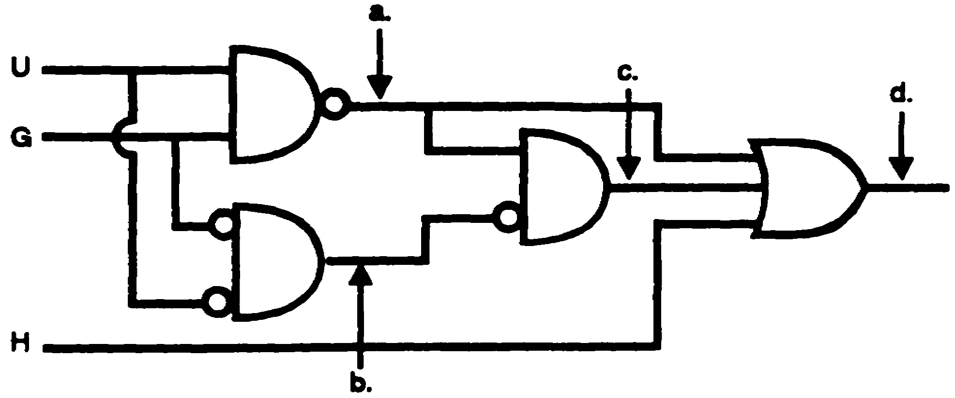
 | a.
 | b.
 | c.
 | d.
a. UG | 27. Convert the logic diagram below to a Boolean expression.
b. U G  c. (UG)(U G)  d. UG+ (UG)(U G)  +H | 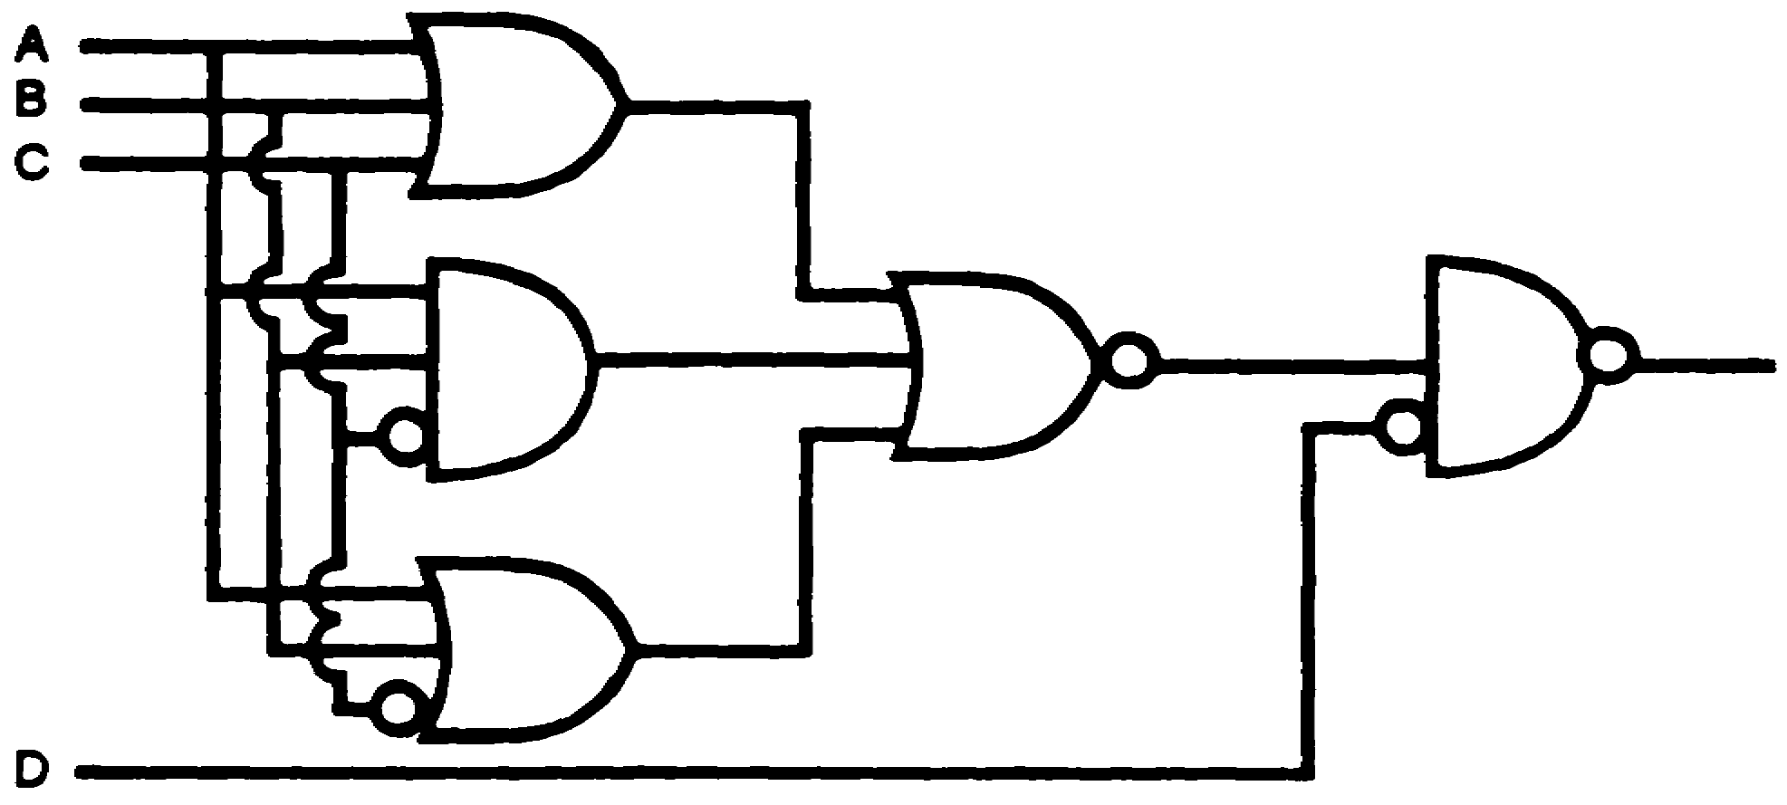
[(A+B+C) +ABC+(A+B+C) ] D

IT 0343 1-18

LESSON 2

CONVERSION OF BOOLEAN EXPRESSIONS TO LOGIC DIAGRAMS

OVERVIEW

LESSON DESCRIPTION:

In this lesson you will learn how to convert Boolean expressions to logic diagrams.

TERMINAL LEARNING OBJECTIVE:

ACTION: Conversion of Boolean expressions to logic diagrams.

CONDITION: Given the information in this lesson.

STANDARD: To demonstrate competency of this task, you must achieve a minimum of 70% on the subcourse examination.

SPECIAL INSTRUCTIONS.

There are exercises on most pages of this lesson, the solution to each exercise immediately follows the exercise. While doing this lesson, use a piece of paper to cover the solution while you work the exercise. After you have completed your work, uncover the solution and check your work.

2-1 IT 0343

1. To convert a Boolean expression to a logic diagram, the technician must first identify the
overall type of circuit associated with the expression. This is necessary for two reasons:
(1) to determine where the expression must first be separated and (2) to determine which
logic symbol must first be drawn to represent the final output Boolean expression
correctly.
To convert a Boolean expression to a logic diagram, the first step for the technician is to
__________________ the __________________ __________________
of circuit associated with the expression.
identify
overall type
2. To construct a logic diagram from a Boolean expression, begin drawing at the right and
work left. If letters in the expression are grouped (by parentheses, brackets, braces,
vincula, etc.), first, separate the group from other groups or letters. For example, Boolean
expression (A+B)(C+D) indicates that the quantity (A+B) grouped together by
parentheses must first be separated from the other group (C+D). Examination of the
expression reveals that it is a two-input AND gate with inputs (A+B) and (C+D). If the
letter X were substituted for the quantity (A+B) and the letter Y were substituted for the
quantity (C+D), the expression would then be represented by XY, a more obvious
expression for a two-input AND gate. Substituting single letters for grouped quantities is
an aid in determining the overall type of circuit the expression represents.

2-3 IT 0343

2. (Continued)
The diagrams below list various types of Boolean expressions, with arrows pointing to the
first separation points; the overall type of circuit the expression represents; and the first
logic symbol which must be drawn (the first logic symbol to the right) to convert from a
Boolean expression to a logic diagram.
Boolean Expression Overall Type of Circuit First Logic Symbol
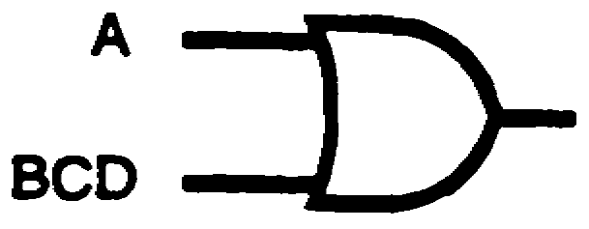
A+BCD OR
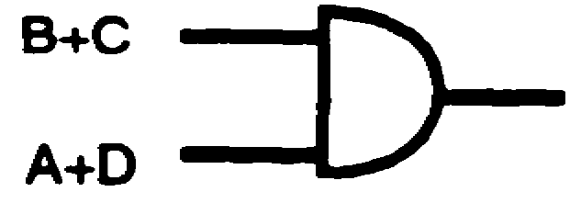
(B+C)(A+D) AND
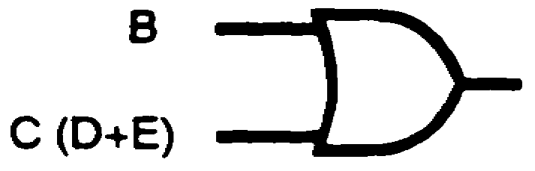
B+C (D+E) OR
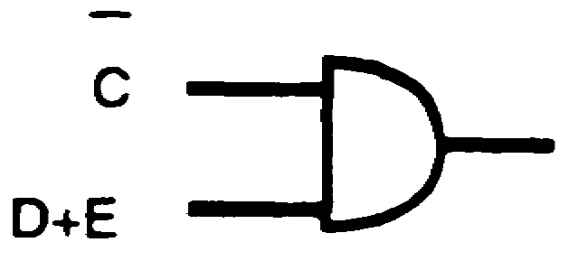
C (D+E) AND
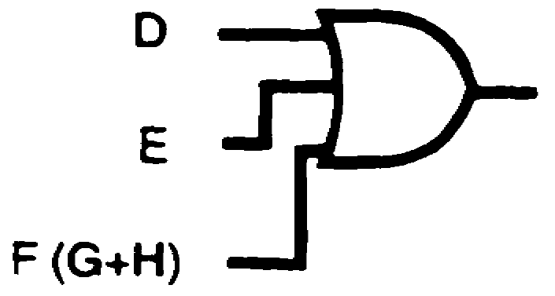
D+E+F (G+H) OR

IT 0343 2-4

2. (Continued)
Boolean Expression Overall Type of Circuit First Logic Symbol
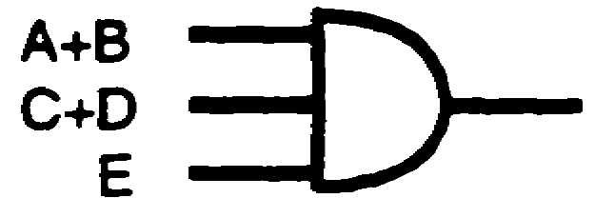
(A+B)(C+D) E AND
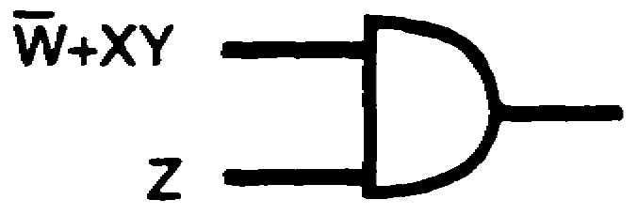
(W+XY) Z AND
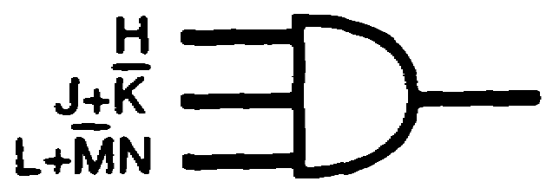
H(J+K)(L+MN) AND
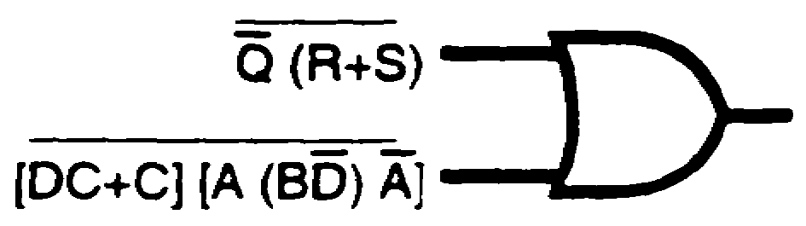
Q (R+S) + ([DC+C] [A (BD) A]) OR
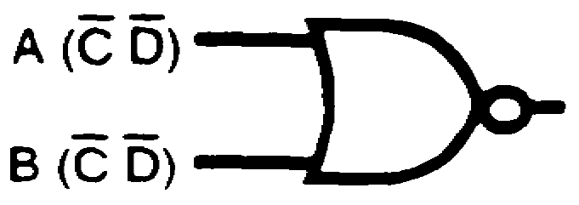
A (C D) + B (C D) NOR
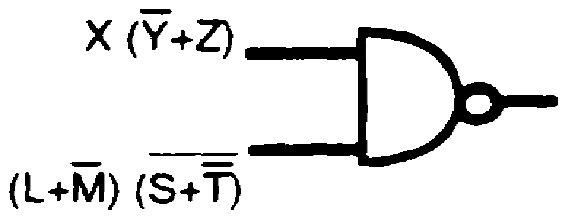
[X (Y+Z) ][ (L+M)(S+T) ] NAND

2-5 IT 0343

2. (Continued)
Convert the Boolean expressions below to logic diagrams in the following sequence:
a. Indicate the first separation point/s, with an arrow or arrows;
b. state the overall type of circuit; and
c. draw the first logic symbol.
Boolean Expression Overall Type of Circuit First Logic Symbol
A (B+CD)
M+NO P
(A+BC)(A+C)
AB+(X+Z)

IT 0343 2-6

SOLUTIONS:
Boolean Expression Overall Type of Circuit First Logic Symbol
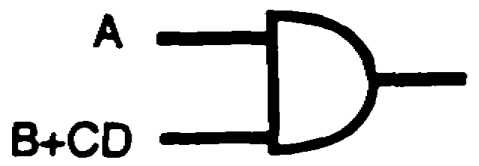
A (B+CD) AND
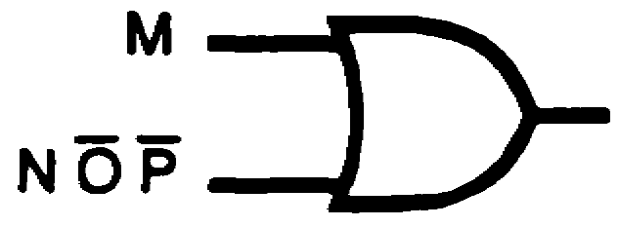
M+NO P OR
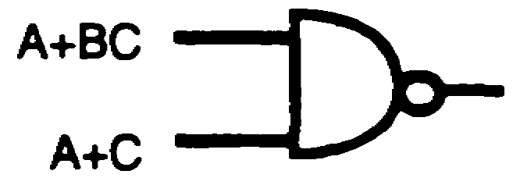
(A+BC)(A+C) NAND
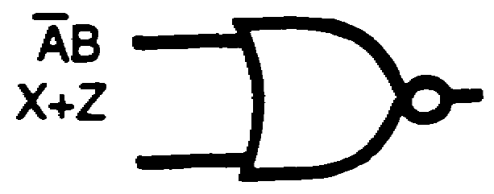
AB+(X+Z) NOR
3. To convert a Boolean expression to a logic diagram, the technician must first
__________________ the ______________ ___________________ of circuit.
identify
overall type
4. A technician is not concerned, to any appreciable extent, in developing original logic. In
the course of his normal job, however, he finds it necessary to apply existing logical Boolean
expressions to particular circuits for troubleshooting. Boolean expressions are converted to
logic diagrams in the same manner previously used to convert diagrams to expressions. The

2-7 IT 0343

4. (Continued)
first step is to identify the overall type of circuit. For example, the Boolean expression
A B C D can easily be recognized as a four-input AND gate. To convert this expression to
a logic diagram, draw a logic symbol for an AND gate and label the inputs A, B, C, and D.
The completed conversion is shown below.
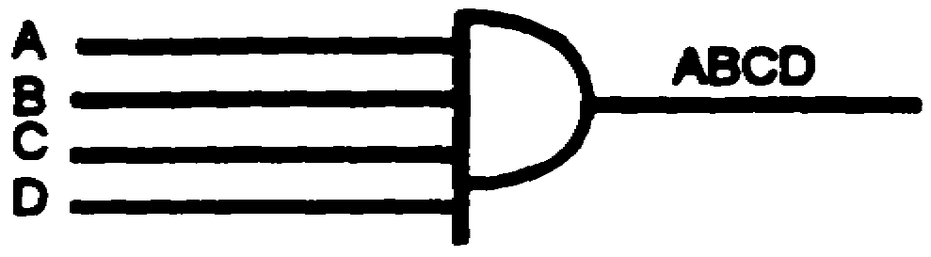
Convert the Boolean expression below to a logic diagram and indicate the inputs.
ALFY
SOLUTION:
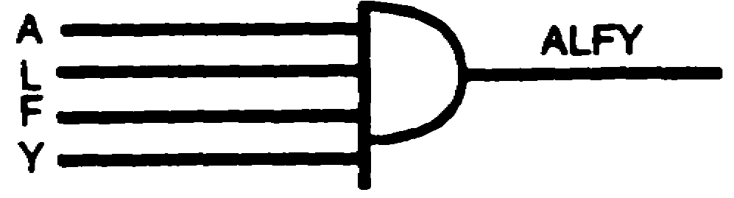
5. When converting from a Boolean expression to a logic diagram, the first step is to identify
the overall circuit type. This does not present much of a problem with first-order logic, but a
thorough understanding of the basics is necessary before proceeding to the more complex
circuits. For example, the Boolean expression A+B+C+D is identified as an OR gate with
four inputs. All that is necessary to convert this expression to a logic diagram is to draw a

IT 0343 2-8

5. (Continued)
logic symbol for an OR gate with four inputs and label the inputs A, B, C, and D. The
completed conversion is shown below.
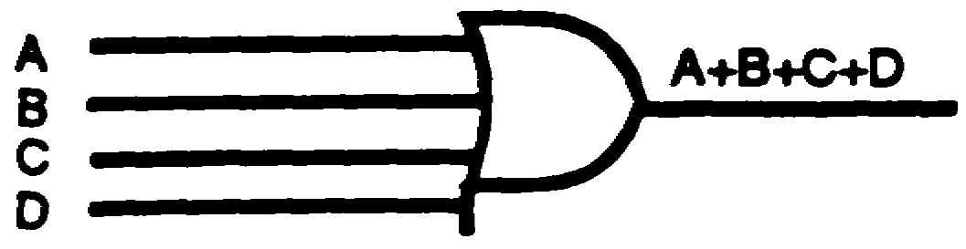
Convert the Boolean expression below to a logic diagram.
B+O+A+T
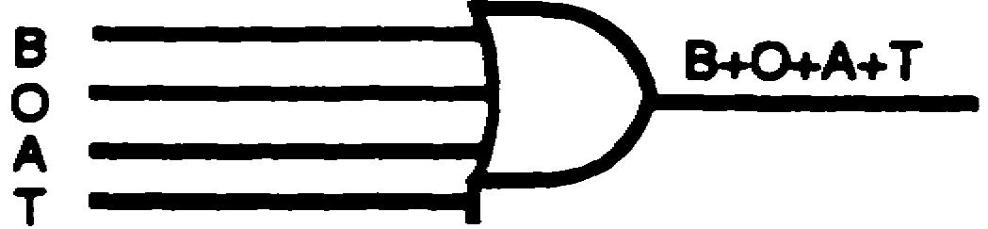
SOLUTION:
6. a. The Boolean expression ABCD represents a ____________________ - input
____________________ gate.
b. Convert the Boolean expression ABCD to a logic diagram.
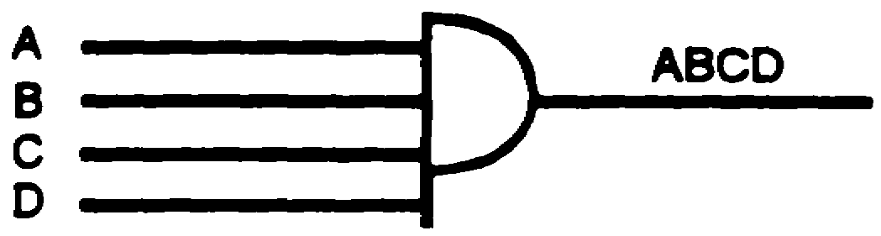
SOLUTION:
a. four b.
AND
7. a. The Boolean expression C+A+J+K represents a ____________________ - input
____________________ gate.
b. Convert the Boolean expression G+A+J+K to a logic diagram.
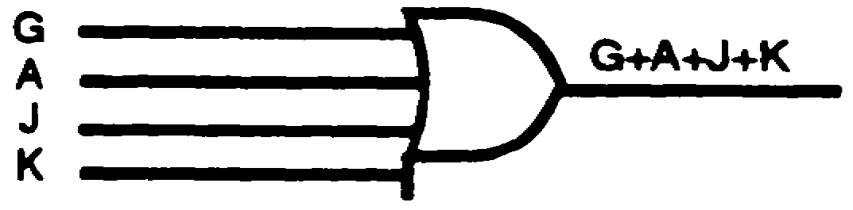
SOLUTION:
a. four b.
OR

2-9 IT 0343

8. After identifying the overall type of circuit, determining where the expression must first be
separated, and drawing the logic symbol which represents the overall circuit, the next step is
to convert all groups or letters within the expression systematically until only single-letter
inputs remain. For example, the Boolean expression AB (C+D) is converted to a logic
diagram as follows:
Step 1. Identify the overall type of circuit.
a. A B (C+D) - this signifies an AND gate.
b. The AND gate contains three inputs-A, B, and quantity (C+D).
c. The logic AND symbol with three inputs is shown below.
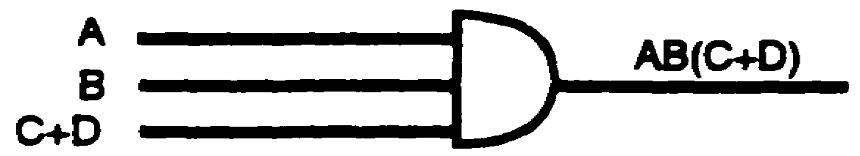
NOTE: Input C+D is now without parentheses, since it has been separated
from the other group and no longer needs a sign of grouping.
Step 2. Identity the input C+D.
a. C + D- this signifies an OR gate.
b. The OR gate contains two inputs-C and D.
c. Draw the logic OR symbol with two inputs as shown below.
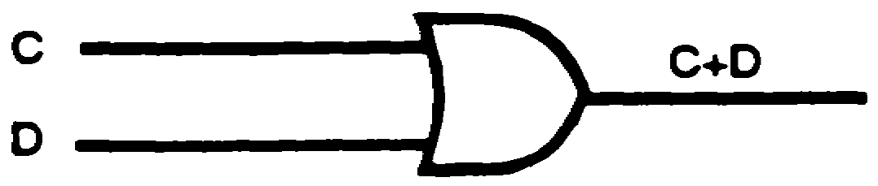

IT 0343 2-10

8. (Continued)
Step 3. Connect the output of the OR gate (step 2) to the input of the AND gate (step 1).
The completed logic diagram is shown below.
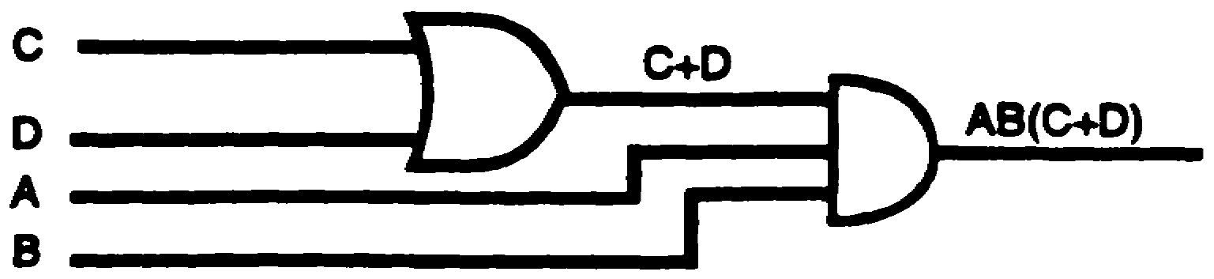
Convert the Boolean expression below to a logic diagram.
(U+S) A
SOLUTION:
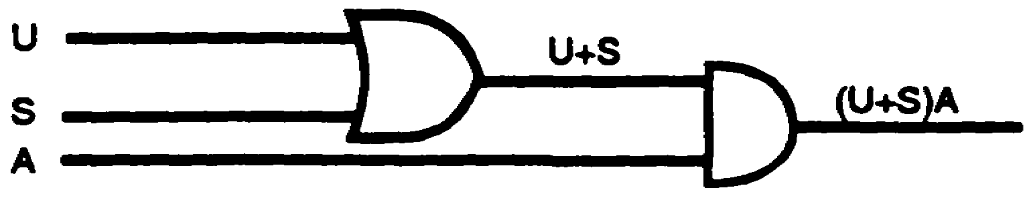
9. The Boolean expression (A + L) E represents a ____________ - input ____________
gate.
Two AND
10. Convert the Boolean expression below to a logic diagram.
(A + L) E
SOLUTION:
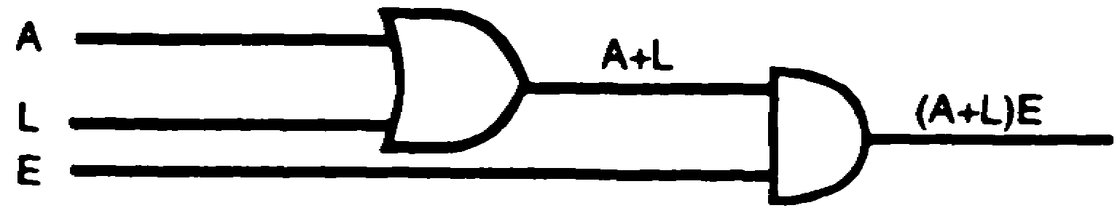

2-11 IT 0343

11. To convert the Boolean expression D+EF to a logic diagram, it is first necessary to identify
the overall circuit as an OR gate (+) with two inputs, D and EF. Input D is separated from
input EF by drawing the OR-logic symbol as illustrated below.
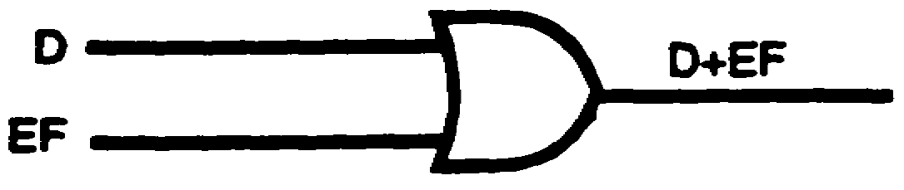
The output expression must be separated until only single-letter inputs- remain. When
letters are grouped together, as in the example D+EF, the groups must first be separated
from other groups or letters. This is accomplished as illustrated in the figure above: input
D is separated from input EF. Now, input EF must be identified and put into proper logic-
diagram form. EF by itself is identified as an AND gate with two inputs, E and F. Input E is
separated from input F by drawing the AND-logic symbol as shown below.

NOTE: Only single-letter inputs remain.
The two symbols are combined to represent the original Boolean expression D+EF by
drawing the output of the AND gate as one input (EF) to the OR gate as shown below.
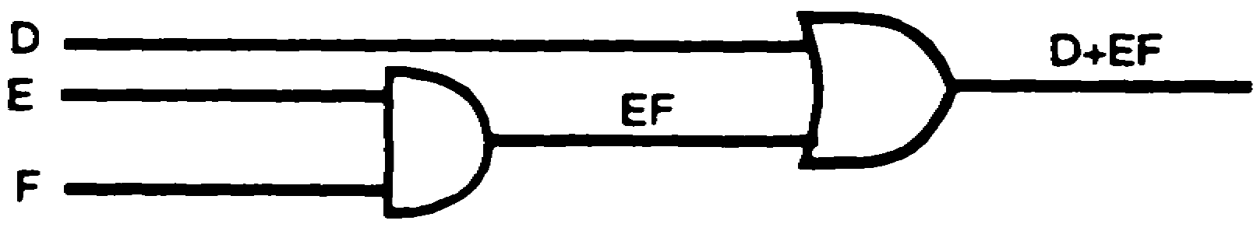
Convert the Boolean expression below to a logic diagram.
EAS+Y

IT 0343 2-12

SOLUTION:
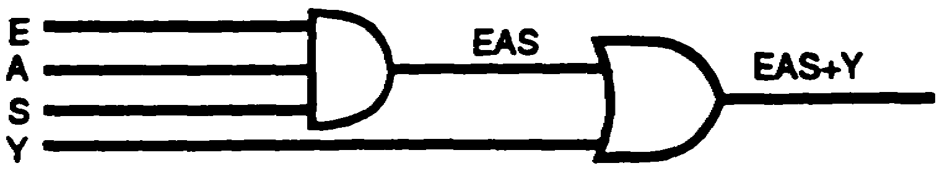
12. The Boolean expression BAS+C represents a _____________________ -input
__________________ gate.
two
OR
13. Convert the Boolean expression below to a logic diagram.
BAS+C
SOLUTION:
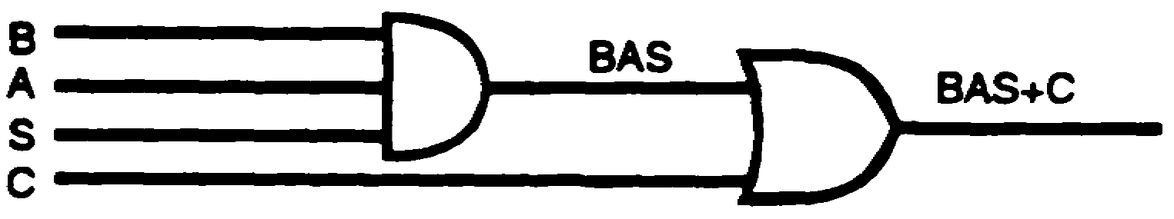
14. The three-input overall OR-gate Boolean expression, AB+C+D, is converted to a logic
diagram by the step-by-step procedure previously discussed.
Step 1. Identify the overall type of circuit.
a. AB + C + D-this signifies a three-input OR gate.
b. The logic OR-gate symbol with three inputs is shown below.
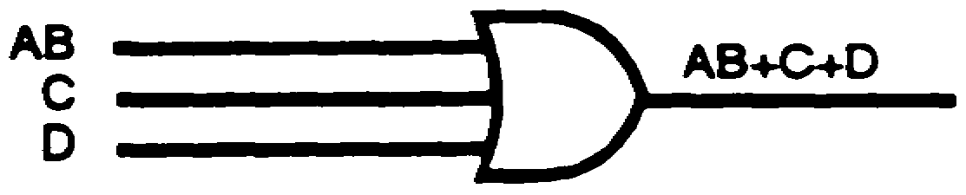

2-13 IT 0343

14. (Continued)
Step 2. Identify input AB.
a. A B -this signifies a two-input AND gate.
b. The logic AND-gate symbol with two inputs is shown below.
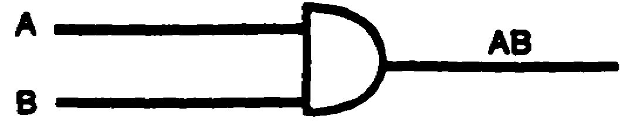
Step 3. Connect the output of the AND gate (step 2) to the input of the OR gate (step 1.)
The completed logic diagram is shown below.
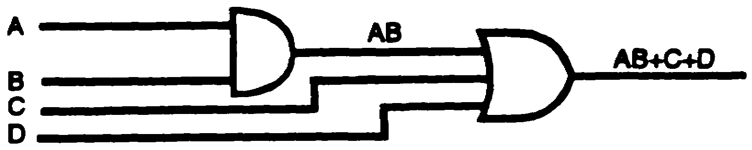
Convert the Boolean expression below to a logic diagram.
GUM+P+Y
SOLUTION:
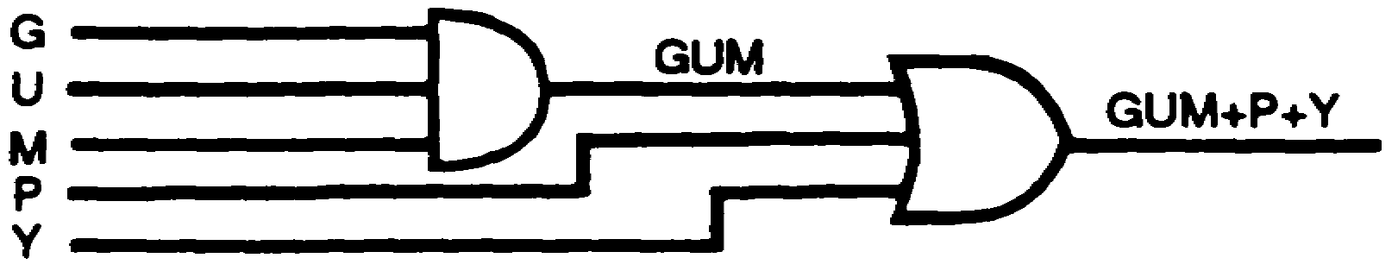
15. The Boolean expression FAS+T+Y represents a ___________________ -
input ___________________ gate.
three
OR

IT 0343 2-14

16. Convert the Boolean expression below to a logic diagram.
FAS+T+Y
SOLUTION:
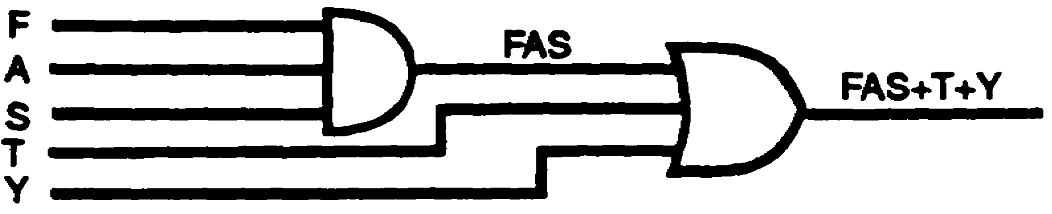
17. The Boolean expression (AB+C) D is identified as an overall two-input AND gate. Note
that the quantity (AB+C) which indicates a two-input OR gate must be treated as a
separate quantity when converting from the Boolean expression to a logic diagram. The
expression is converted to a logic diagram, following a step-by-step procedure as shown
below.
Step 1. Identify the overall type of circuit.
a. (AB+C) D-this signifies a two-input AND gate.
b. The logic AND-gate symbol with two inputs is shown below.
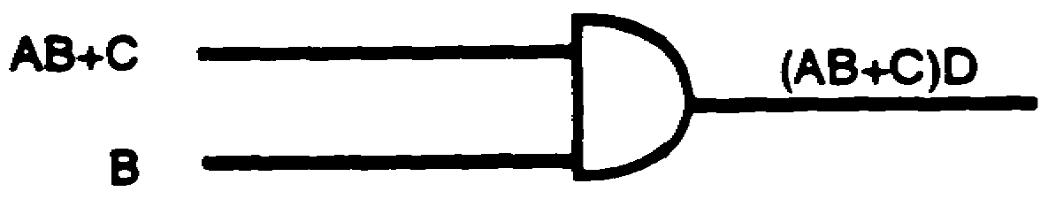
Step 2. Identity the quantity AB+C.
a. AB + C-this signifies a two-input OR gate.
b. The logic OR-gate symbol with two inputs is shown below.
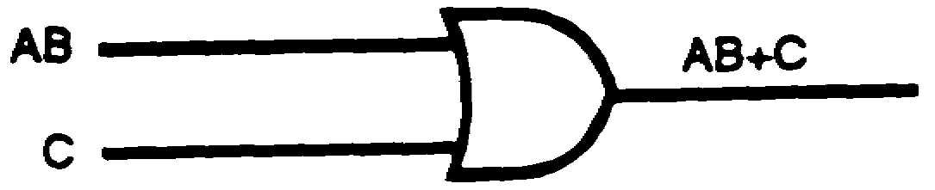

2-15 IT 0343

17. (Continued)
Step 3. Connect the output of the OR gate (step 2) to the input of the AND gate (step 1)
as shown below.
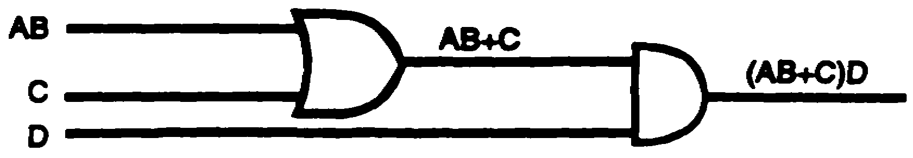
Step 4. Identify the quantity AB.
a. A B-this signifies a two-input AND gate.
b. The logic AND-gate symbol with two inputs is shown below.
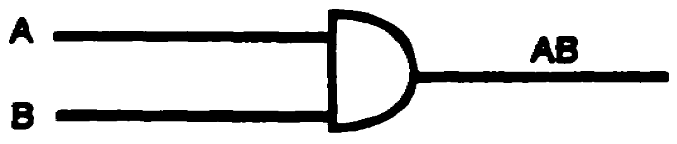
Step 5. Connect the output of the AND gate (step 4) to the input of the OR gate (step 3).
The completed conversion is shown below.
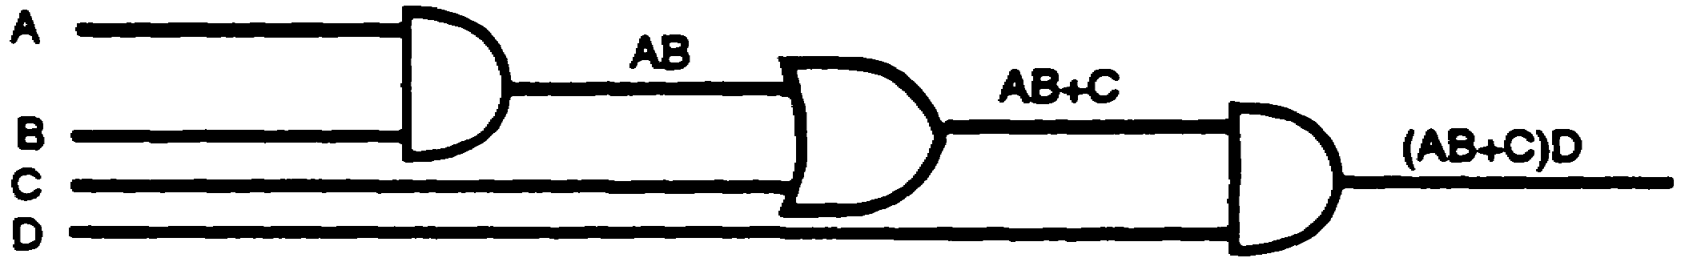
Convert the Boolean expression below to a logic diagram.
(G+IR) L
SOLUTION:
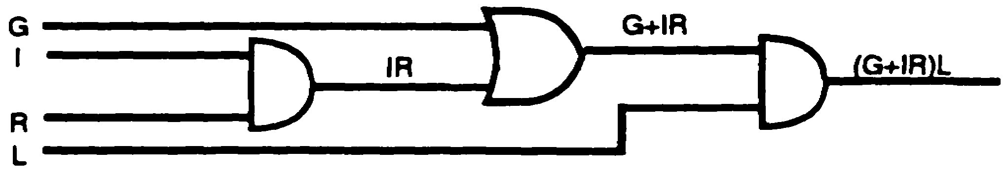

IT 0343 2-16

18. The Boolean expression (B+IR) D represents an overall _________________ - input
_________________ gate.

two
AND

19. Convert the Boolean expression below to a logic diagram.
(B+IR) D
SOLUTION
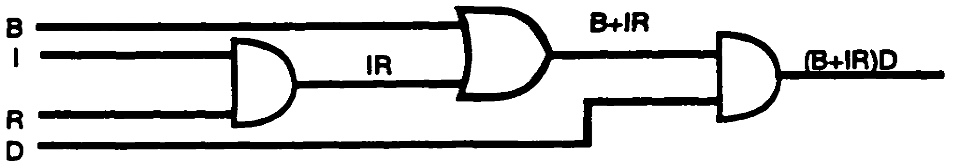
20. When converting a Boolean expression to a logic diagram, pay particular attention to the
signs of grouping; i.e., parentheses, brackets, braces, vincula, etc. Never separate factors
within a group until that group has been separated from the rest of the expression. With
this in mind, the Boolean expression (R+S) T+V is systematically converted to a logic
diagram as follows:
Step 1. Identify the overall type of circuit.
a. (R+S) T + V-this signifies a two-input OR gate.
b. The logic Or-gate symbol with two inputs is shown below.
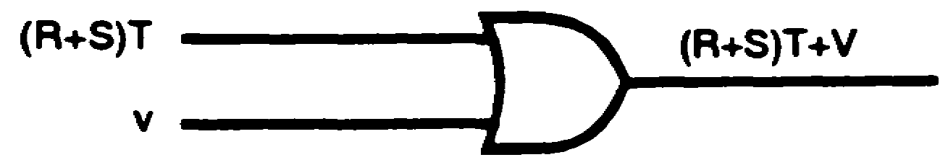

2-17 IT 0343

20. (Continued)
Step 2. Identify the quantity (R+S) T.
a. (R+S) T-this signifies a two-input AND gate.
b. The logic AND-gate symbol with two inputs is shown below.
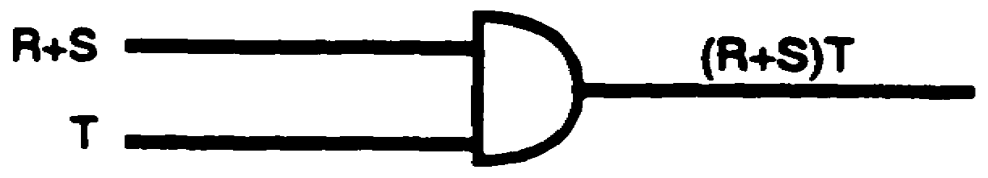
Step 3. Connect the output of the AND gate (step 2) to the input of the OR gate (step 1)
as shown below.
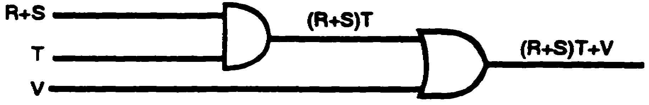
Step 4. Identify the quantity R+S.
a. R + S-this signifies a two-input OR gate.
b. The logic OR-gate symbol with two inputs is shown below.
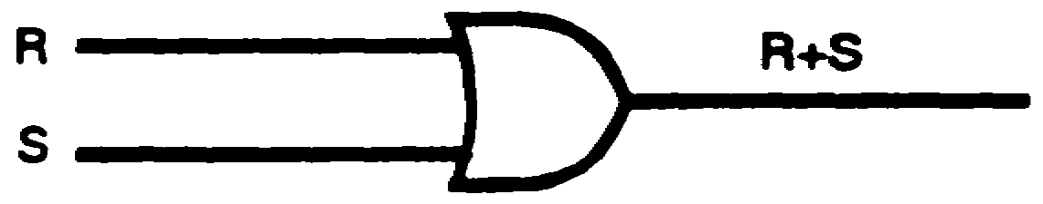
Step 5. Connect the output of the OR-gate (step 4) to the input of the AND gate (step 3).
The completed conversion is shown below.
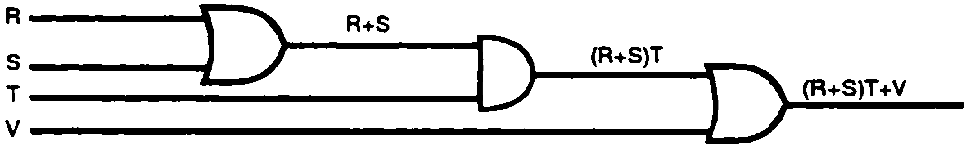
Convert the Boolean expression below to a logic diagram.
B+O (Y+S)

IT 0343 2-18

SOLUTION:
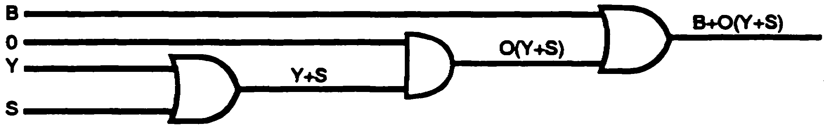
21. The Boolean expression S+T (A+G) represents an overall _______________ input
_______________ gate.
two
OR
22. Convert the Boolean expression below to a logic diagram.
S+T (A+G)
SOLUTION:
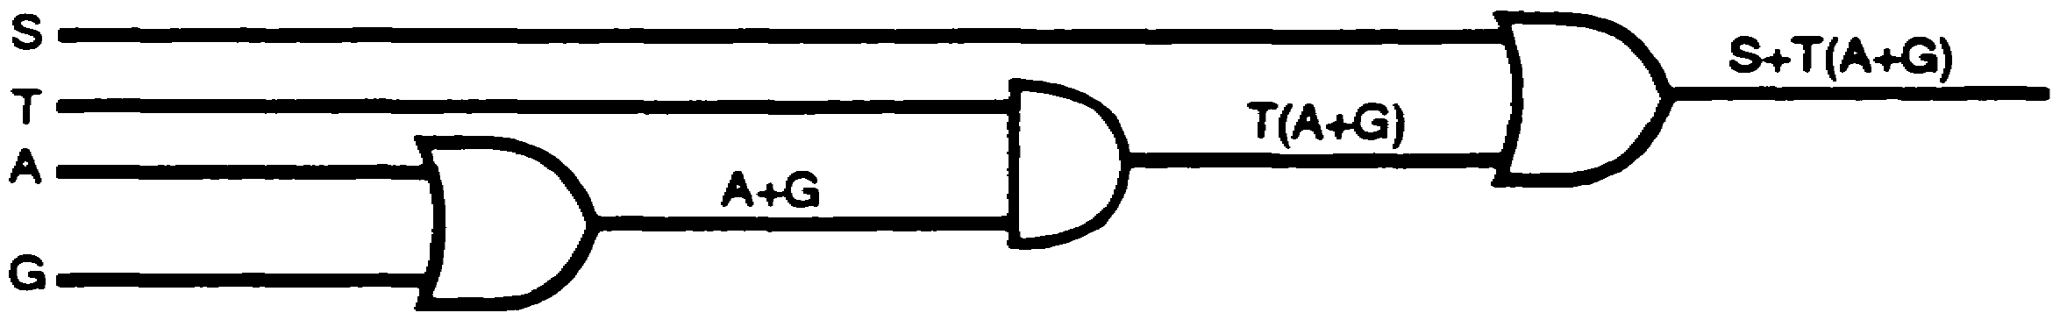
23. The vinculum is a sign of grouping. When a Boolean expression contains a vinculum,
such as ABC+DE, observe the following steps when converting to a logic diagram:
a. First, separate the groups until the group or letter which has the vinculum over it is
isolated from the rest of the expression. For example, in the Boolean expression
ABC+DE, the portion of the expression which contains the vinculum is isolated as
follows:

2-19 IT 0343

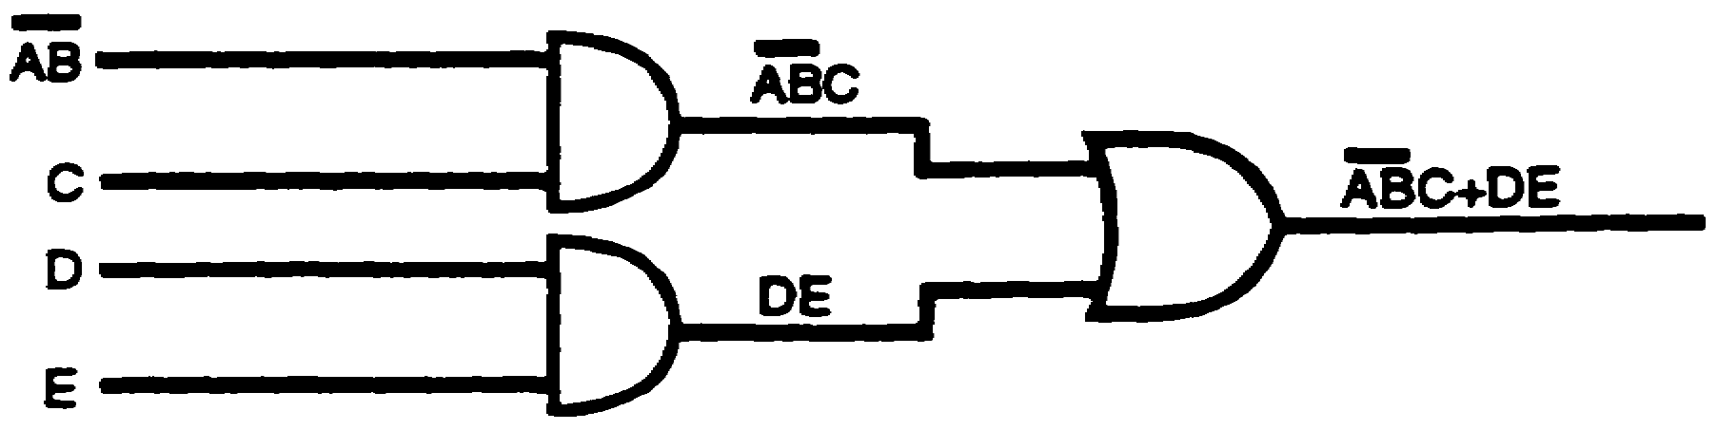
23. (Continued)
AB is now
isolated.
b. Next, draw the logic symbol which will remove the vinculum--in this example, a NAND
symbol. The inverter symbol removes the vinculum. Remember, nothing under a
vinculum may be separated until the vinculum has been removed. The completed
logic diagram is shown below.
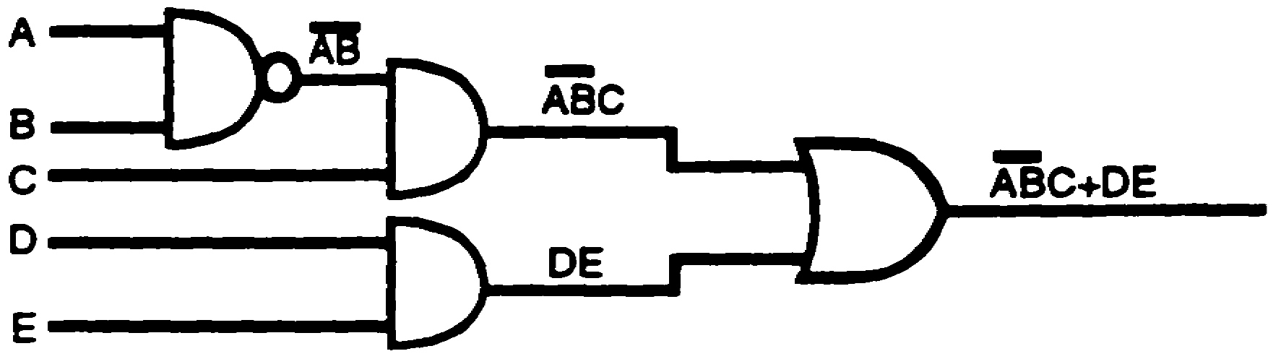
AB is indicative of a NAND gate because of the vinculum which extends over both letters;
however, AB could also have been drawn correctly by placing an inverter at any point
from the output of the ANDed AB to the input of the next AND gate, as shown below.
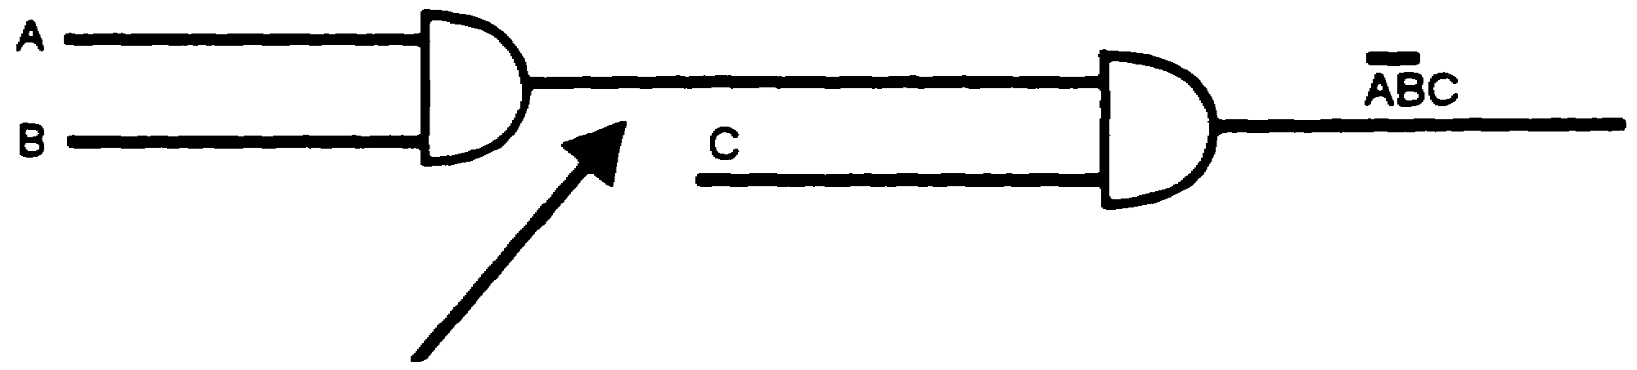
An INVERTER 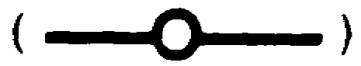 could have been
placed at any point along this line to make ABC a
true statement. Normally, it is at the output of gate.
Convert the Boolean expression below to a logic diagram.
H+ART

IT 0343 2-20

SOLUTION:
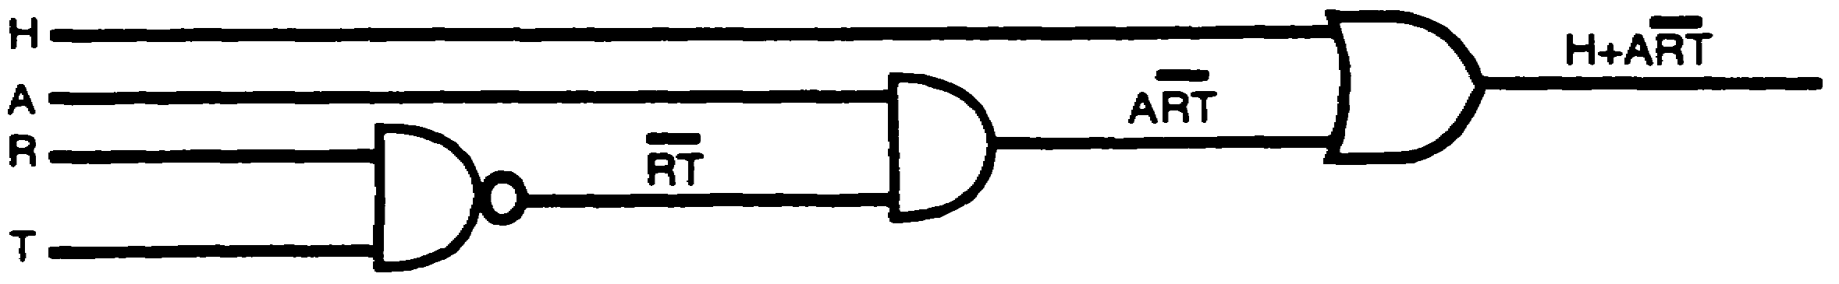
24. The Boolean expression A+BCD represents an overall __________________ - input
__________________ gate.
two
OR
25. Convert the Boolean expression below to a logic diagram.
A+BCD
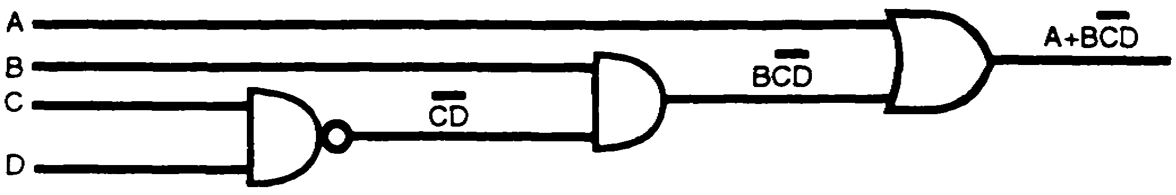
SOLUTION:

26. When more than one vinculum covers part of an expression, such as (AB+C) D, the
uppermost vinculum is removed first. Remember that nothing under a vinculum can be
separated until the vinculum has been removed by using the appropriate logic symbol.
The Boolean expression (AB+C) D is converted to a logic diagram as follows:
a. The expression is first identified as a two-input AND gate containing inputs (AB+C) and
D. Draw the logic AND symbol and label the inputs as shown below.
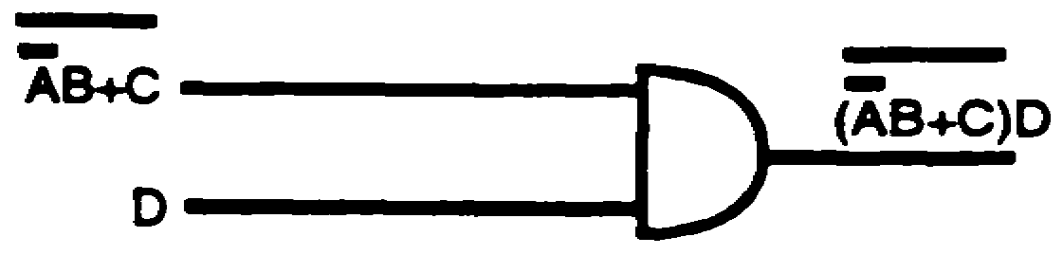

2-21 IT 0343

26. (Continued)
b. Input AB+C is identified by the uppermost vinculum as the output from a NOR gate.
Draw the logic symbol for a NOR gate, label the inputs, and connect the output to the
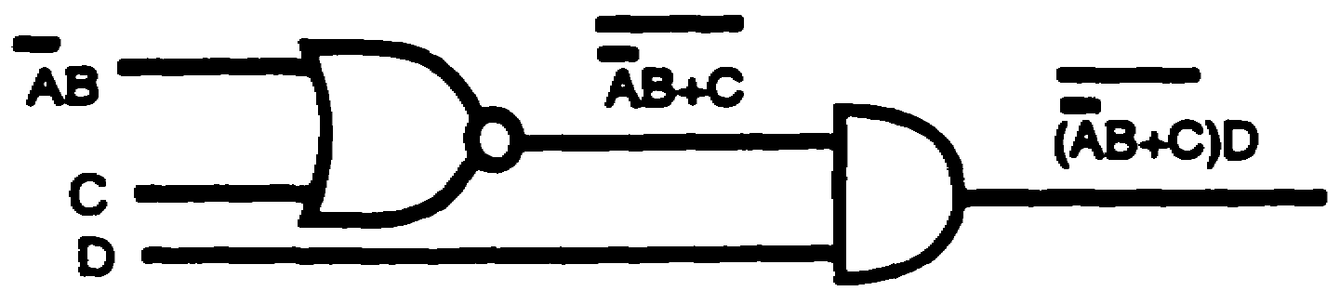
AND gate as shown below.
Input AB is identified as a two-input AND gate which has the A input INHIBITED. Draw the
logic symbol for the AND gate, INHIBIT the A input, and connect the output to the NOR
gate. The completed conversion is shown below.
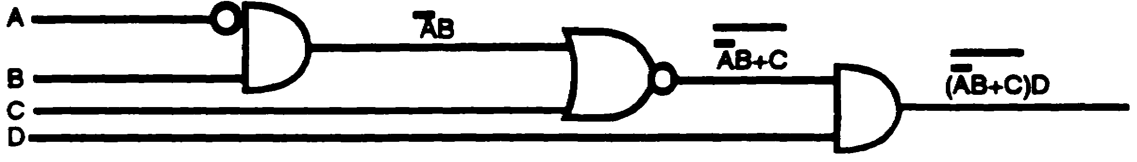
Convert the Boolean expression below to a logic diagram.

(US+N) AVY
SOLUTION:
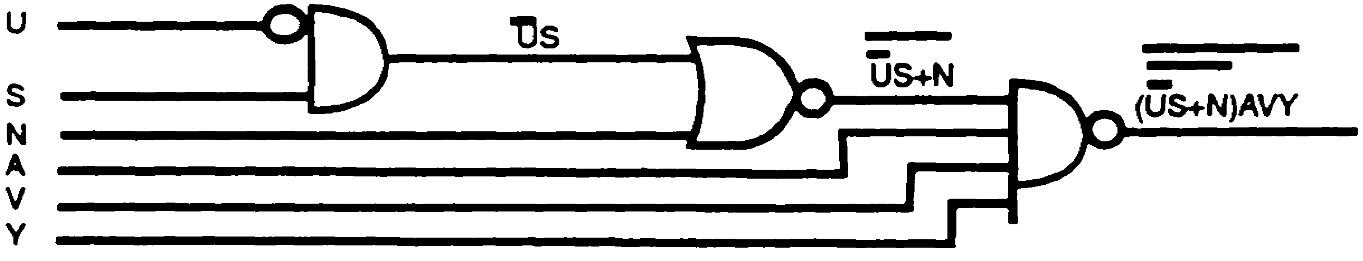

IT 0343 2-22

27. Convert the Boolean expression below to a logic diagram.
(LA+S) ER
SOLUTION:
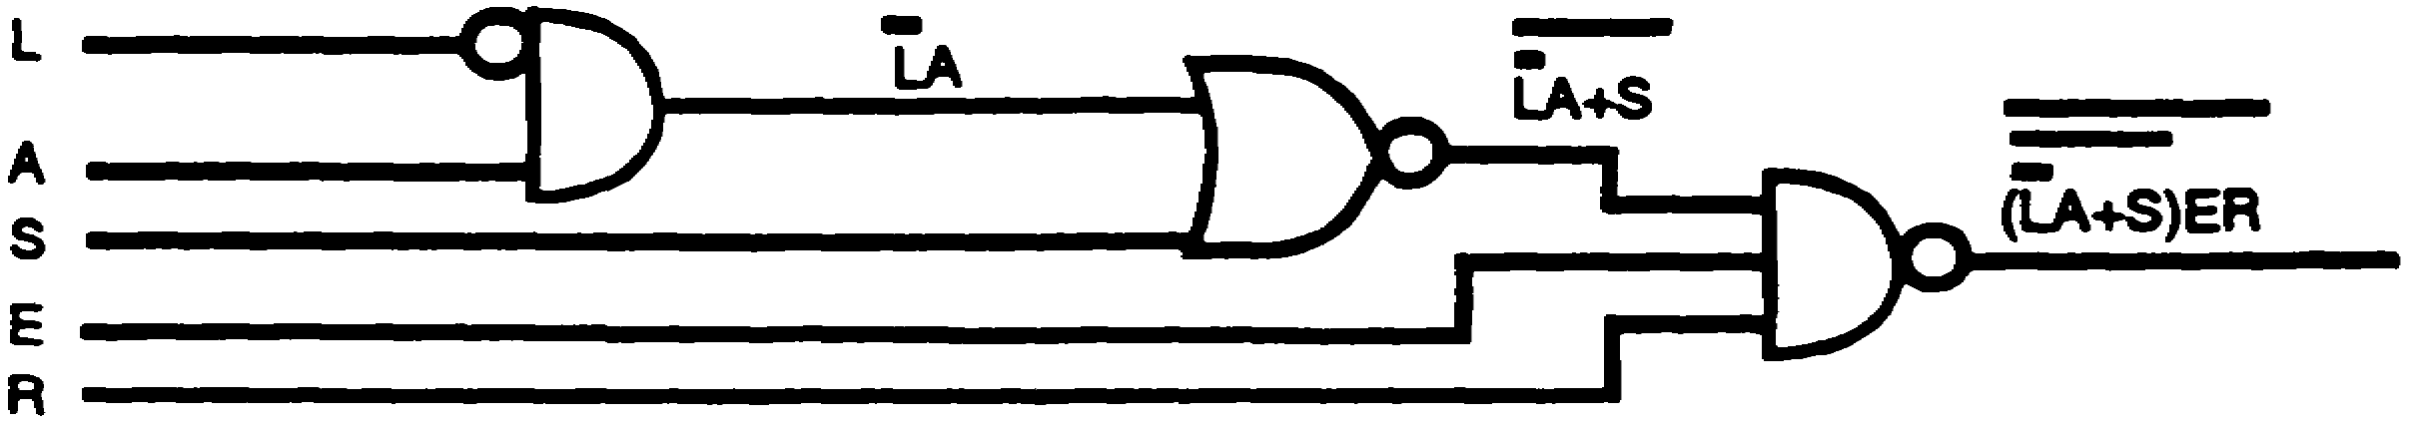
28. The logic diagram which represents the Boolean expression U (SM+A (R+I) + NE] is
drawn systematically and logically as follows:
Step 1. Substituting the letter X for the quantity within brackets [SM+A (R+I) +NE]
simplifies the expression to UX. The vinculum covers the entire two-input
AND gate which is identified as the overall NAND gate shown below.
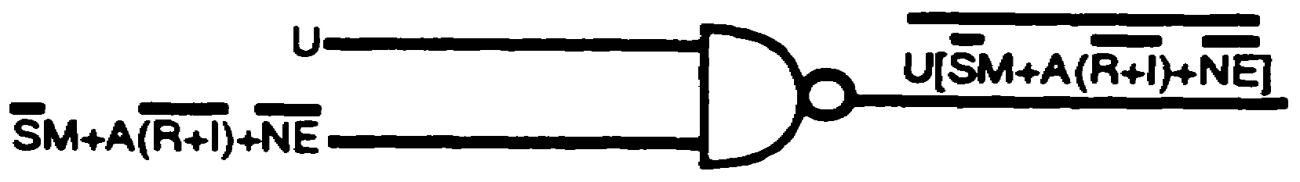

2-23 IT 0343

28. (Continued)
Step 2. Identify input SM+A (R+I) +NE.
a. SM+A (R+I) +NE--this signifies a three-input OR gate.

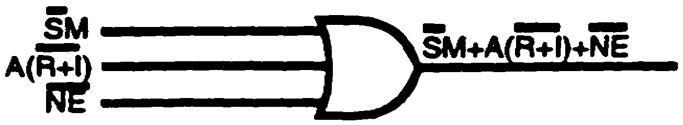
Step 3. Connect the output of the OR gate to the input of the NAND gate as shown
below.
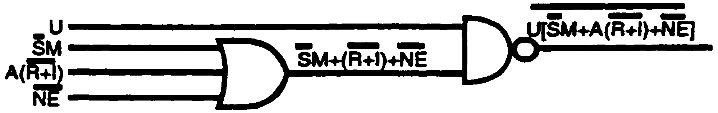
Step 4. Identify input SM.
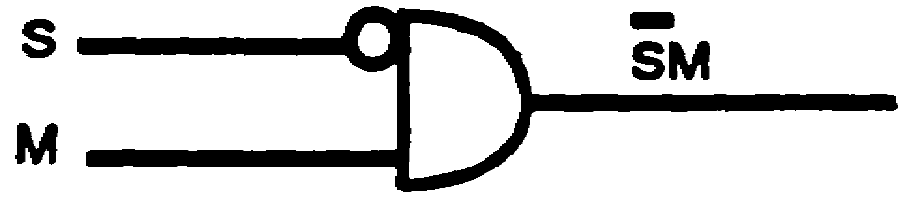
a. S M--this signifies a two-input AND gate.
b. Input S is INHIBITED.
Step 5. Connect the output of the AND gate to the input of the OR gate as shown below.
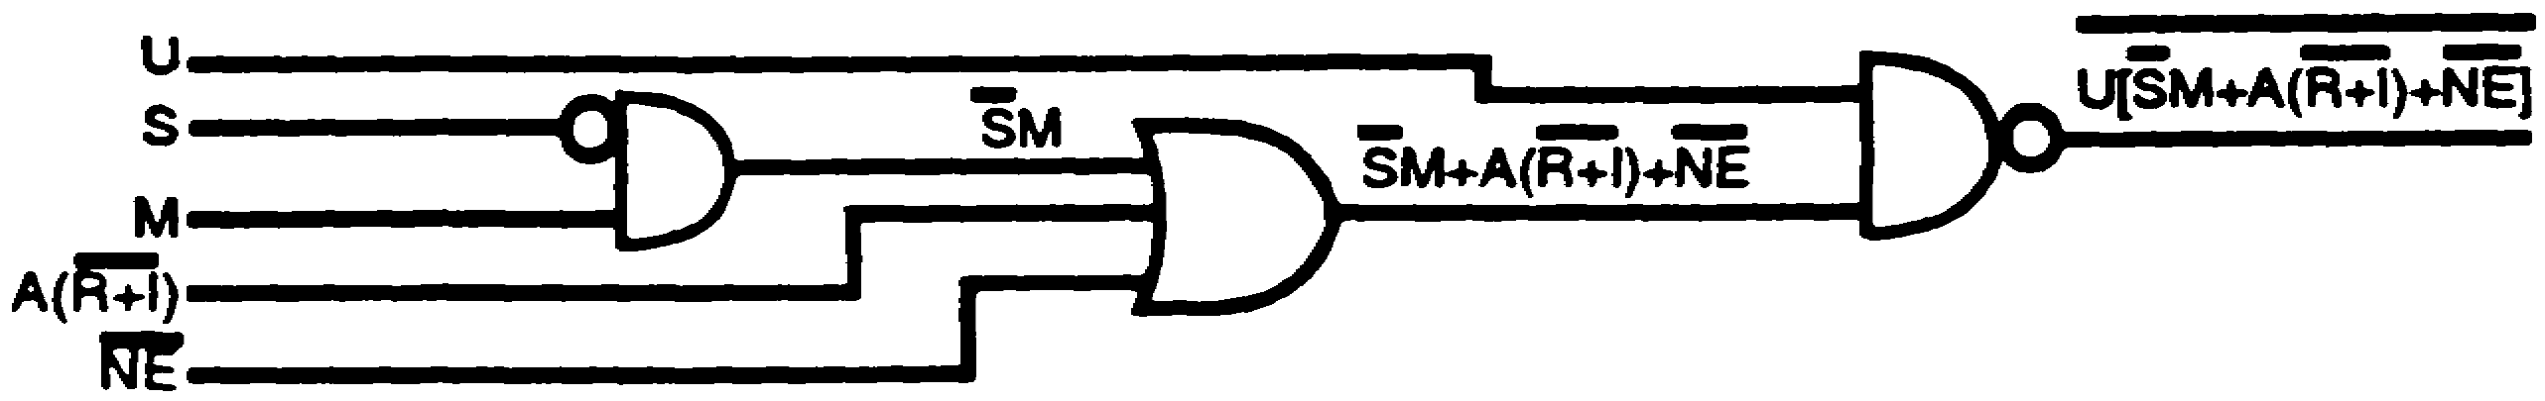
Step 6. Identify input A (R+I).
a. A (R+l) --this signifies a two-input AND gate.
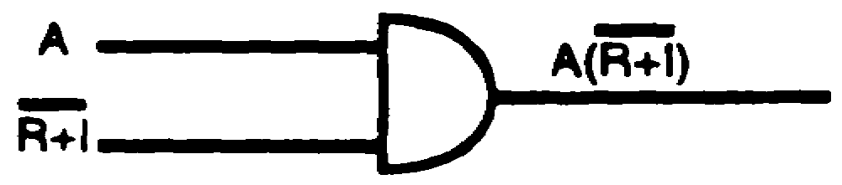
Step 7. Connect the output of the AND gate to the input of the OR gate as shown below.
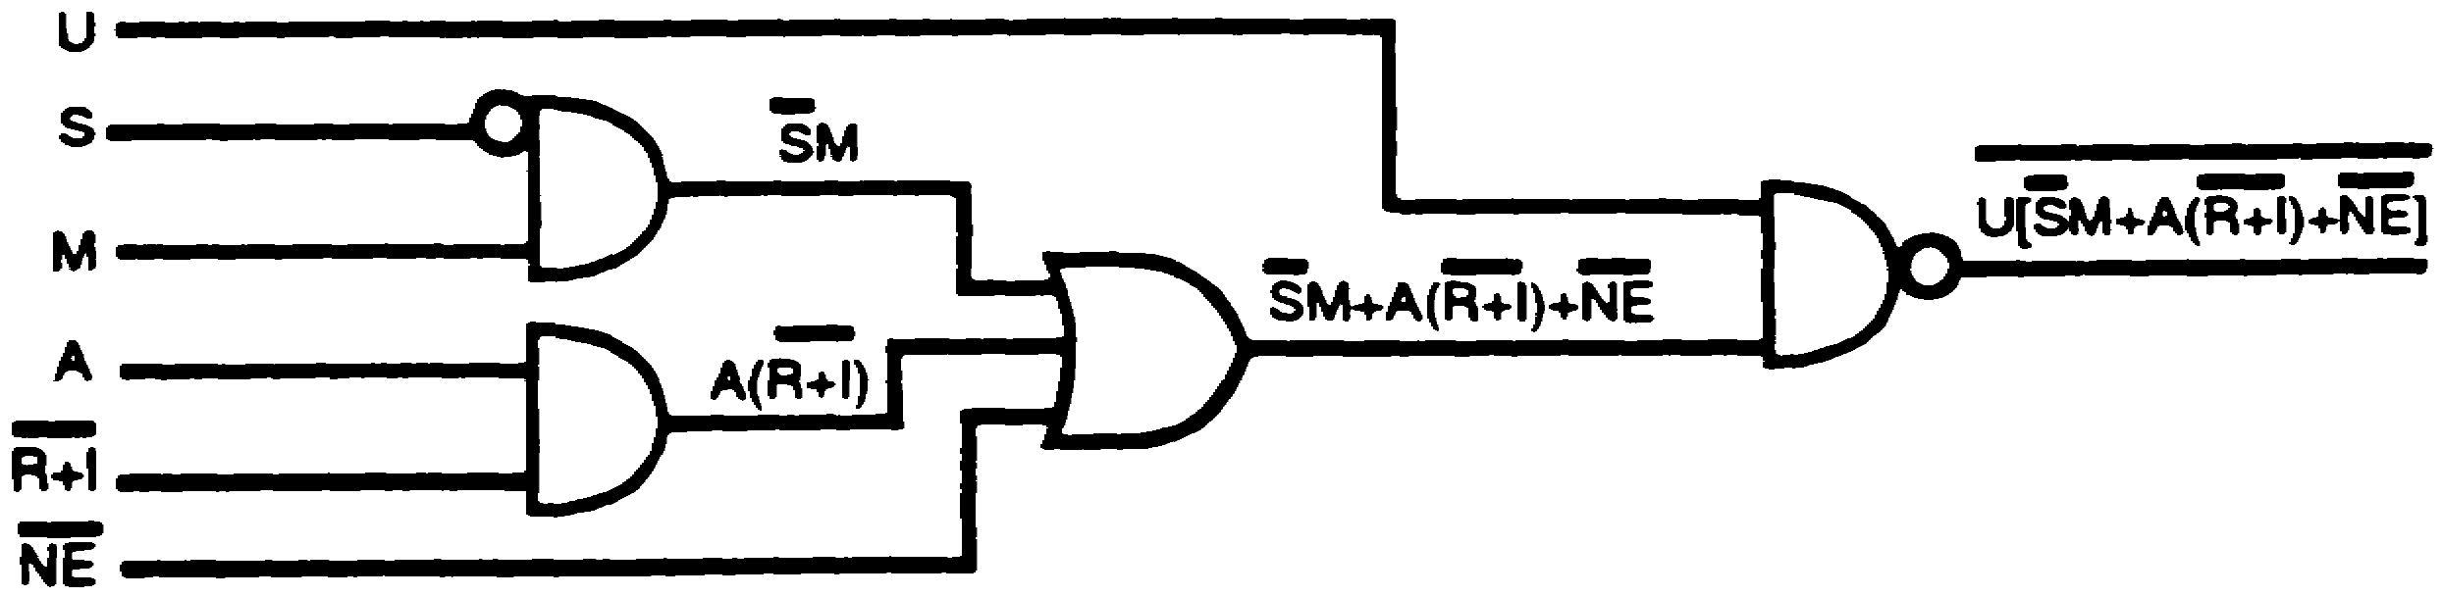

IT 0343 2-24

28. (Continued)
Step 8. Identify input R+I.
a. R+l--this signifies a two-input NOR gate.

Step 9. Connect the output of the NOR gate to the input of the AND gate as shown below.
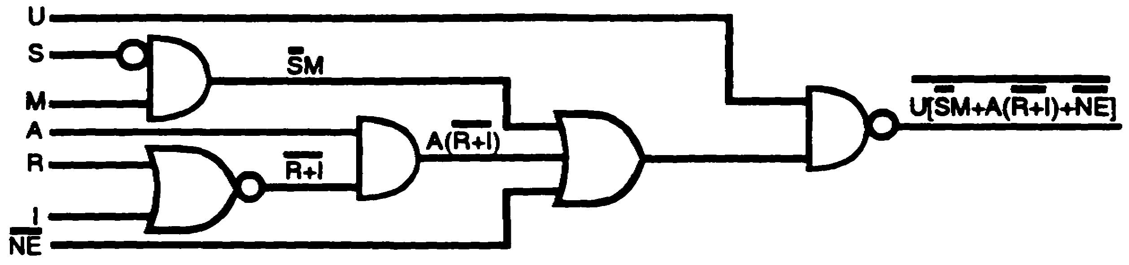
Step 10. Identify input NE.
a. NE-this signifies a two-input NAND gate.
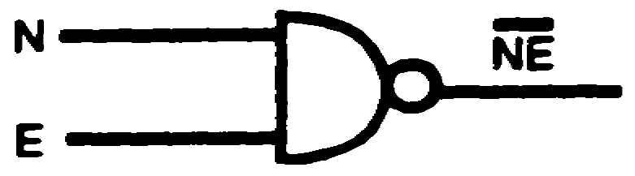
Step 11. Connect the output of the NAND gate to the input of the OR gate as shown
below.
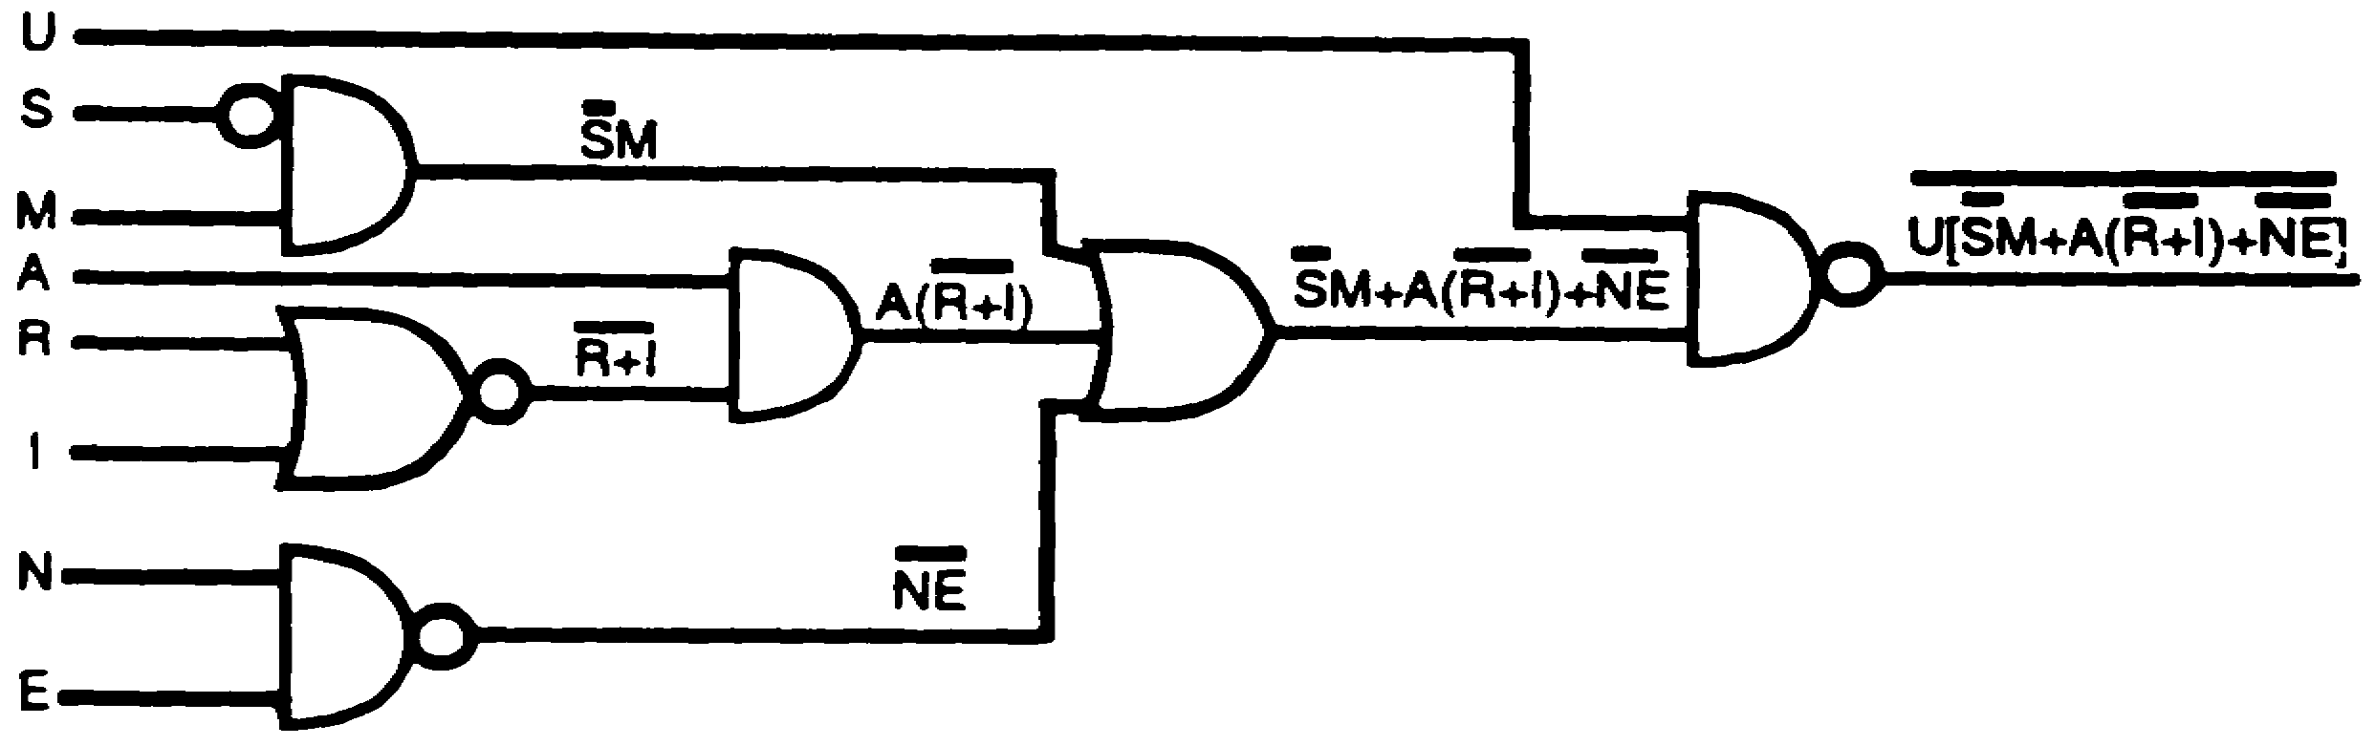
Only single-letter inputs remain, which signifies that conversion is complete.

2-25 IT 0343

28. (Continued)
Convert the Boolean expression below to a logic diagram.
A [BC+C (D+E) +FG]
SOLUTION:
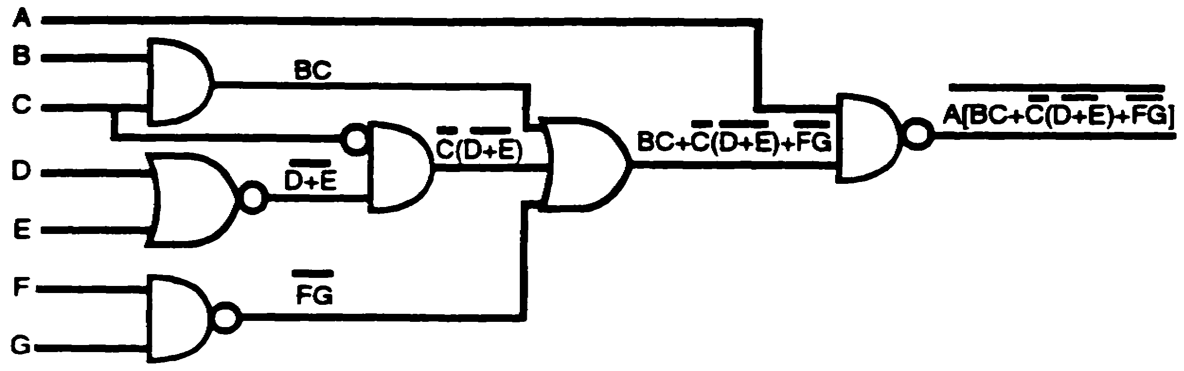
29.
S [TU+U (V+W) +XY]
The Boolean expression above represents an overall ________________ gate.

NAND

IT 0343 2-26

